**Introduction to Sort Algorithms**  
* We won’t cover every sort algorithm that we’re going to cover in the course because a few of them require specific data structures so we’ll cover those later.  
* The sort algorithms we’ll cover in this section can be used to sort arrays.  
* Just a reminder that an algorithm can have multiple implementations - I’m going to show you 1 implementation for each algorithm.

**Bubble Sort (Theory)**  
* The way that bubble sort works and you’re going to see that this is pretty common with sort algorithms, is as the algorithm progresses, it partitions the array into a sorted partition and an unsorted partition.  
* And this is logical partitioning so we don’t create completely separate array instances for the sorted and unsorted.  
* Everything is done - when it comes to bubble sort - using the array that we’re sorting and we partition the array logically.  
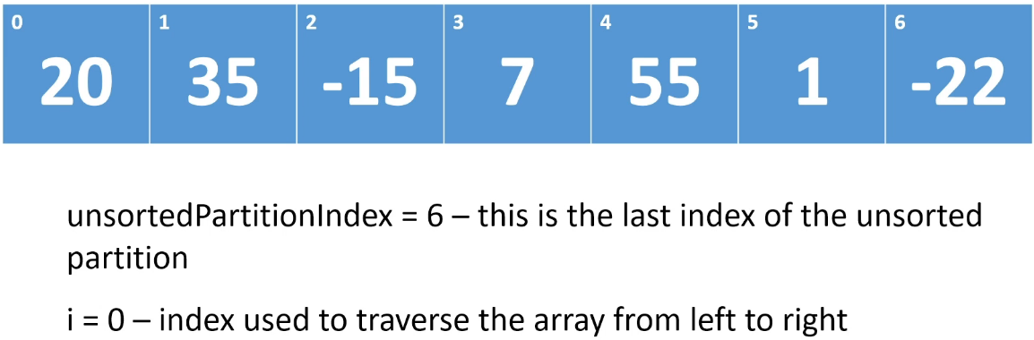  
* The implementation that I’m going to show you starts at the left of the array - at index 0 - that’s where i is and what we do is:  
=> **Compare the element at index 0 with the element at index 1**  
=> **If the element at index 0 is greater than the element at index 1, we swap the elements**.   
=> **If it’s less, we don’t do anything** because we want to more larger elements towards the end of the array - towards the right - because we’re sorting in **ASCENDING order**.  
=> **Then we increment i**.  
* So now we’re going to compare the element at position 1 with the element at position 2.  
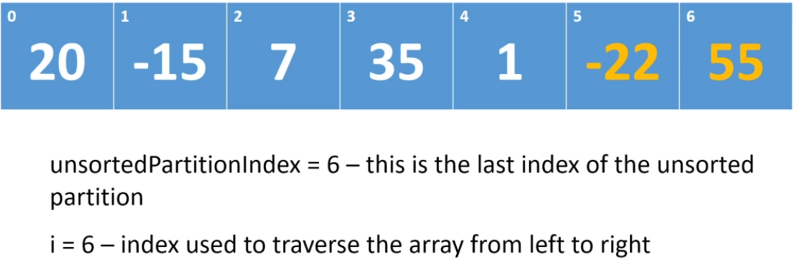  
* Once we get to the end of the array, i = unsortedPartitionIndex so we stop. We have completed the first traversal of the array and at the end of that traversal, the last element in the array is in its correct position.  
=> **So at this point the GREATEST element in the array will be at index (length - 1)**.  
=> Now we’re going to **decrement the unsortedPartitionIndex**. Because the old unsortedPartitionIndex position is now sorted. And so the logical partition is going to be between the element at index 5 and the element at index 6.   
=> **Everything from the index 5 down to the front of the array is in the unsorted partition**.  
=> **Everything at array index 6 and to the right is in the sorted partition**.

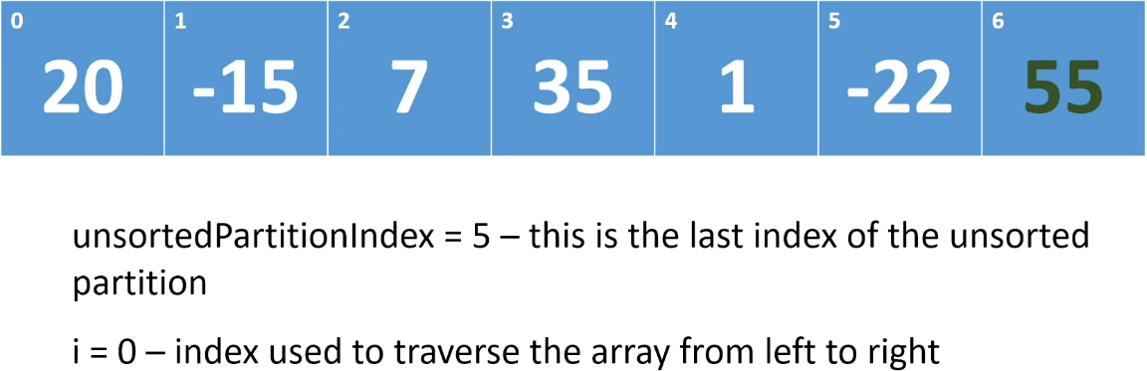  
* On the next traversal, we can see that 55 is now in the sorted partition.  
* And we set i = 0.  
* And we decrement the unsortedPartitionIndex.  
* At the end of this traversal, everything in array index 0 to (unsortedPartitionIndex - 1) (0 - 4) is in the unsorted partition and everything from the unsortedPartitionIndex (5 - 6) up to the end of the array is in the sorted partition.  
* And again we set i = 0 and decrement the unsortedPartitionIndex so to 4.  
* We continue until the sorted partition is the entire array and then we’re done.  
* It’s called a bubble sort because depending on which way you’re sorting (in our case the larger)   
**values in the array will bubble up to the end of the array**.  
* Another way of looking at it is to flip the array vertically so we take the array and we flip it counterclockwise so that array element 0 is at the bottom and array element 6 is at the top.  
* And another way of looking at it is saying that the large values are bubbling up to the top of the array.  
* **As I said, there are some variations where the array is sorted from right to left so the traversal goes from right to left and sometimes the smaller elements are bubbled to the front of the array rather than the larger elements being bubbled to the back of the array, but the same steps are used. It’s the same algorithm**.  
* Let’s look at how this algorithm performs.  
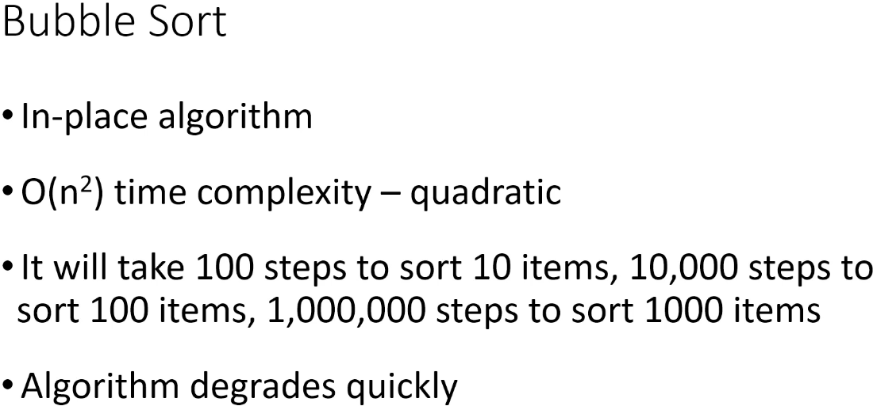  
**In-place** **algorithm => we’re logically partitioning the array, we don’t have to create another array in order to perform the sort. And so when it comes to memory, this is an in-place algorithm**.  
* When we’ll look at the implementation, we do create some local variables but that’s okay.   
=> **It’s an in-place algorithm if the extra memory that you need doesn’t depend on the number of items you’re sorting. If the extra memory you’re using doesn’t increase with the as the number of items in the array increases, then it’s still an in-place algorithm**.

**Bubble Sort (Implementation)**  
**(Implemented my own version before watching this video)**  
* I’m going to show you 1 implementation, there are other implementations of this algorithm, there’ll be a different implementation to sort in descending order. Some of the implementations expand the sorted partition from left to right rather than from right to left.  
* Because in our implementation we’re bubbling large values to the end of the array, the sorted partition is growing from right to left.  
* There’s the outer loop - for each iteration of the outer loop, we want to traverse the array and we want to bubble the largest value that’s unsorted into the sorted partition, so to the end of the array. That’s what the inner loop is going to do.  
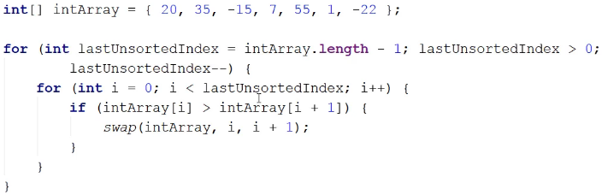  
* The time complexity of Bubble Sort is quadratic. So the absolute worst case is it will take N squared steps where N is the number of items we’re sorting.  
* You might look at the code and say: well it’s not N squared, it’s actually less than that because the sorted partition is growing after each iteration of the outer loop and the inner loop doesn’t cross into the sorted partition. So the inner loop is doing less work as the algorithm progresses. That’s right.  
=> But remember that when it comes to determining the time complexity of an algorithm, we’re not doing math. We don’t want the absolute precise expression. What we’re trying to do is get some sense of how the number of steps grows as the number of items we have to sort grows.  
=> So we kind of want a general idea, we want to be able to say this is a linear algorithm, or this is a quadratic algorithm, or this is a logarithmic algorithm, or this is a constant algorithm.  
=> We’re looking for approximations.  
* The algorithm grows in a quadratic way as the number of items increases, the pattern isn’t linear, it’s not logarithmic, and it’s certainly not constant. And so we still consider Bubble Sort to be a quadratic algorithm and in fact this implementation has a little bit of an optimization.  
=> Strictly speaking, Bubble Sort wants us to traverse the entire array every single time. It doesn’t really pay attention to where the sorted partition is.  
* This implementation does pay attention to where the sorted partition is and it doesn’t cross into the sorted partition because it doesn’t have to. Those elements are already sorted.  
* **One tip when it comes to determining time complexity - look at how many loops there are. Because normally each loop corresponds to N and so if you have only one loop, then it’s linear time complexity, if you have 2 loops, then it’s N * N so that’s quadratic time complexity**.  
* Here we have 2 loops and so just at a glance we can kind of guess that this is a quadratic time complexity.

**Stable vs. Unstable Sort Algorithms**  
* Stable vs. Unstable comes into play when you have duplicate values in the data that you’re sorting.  
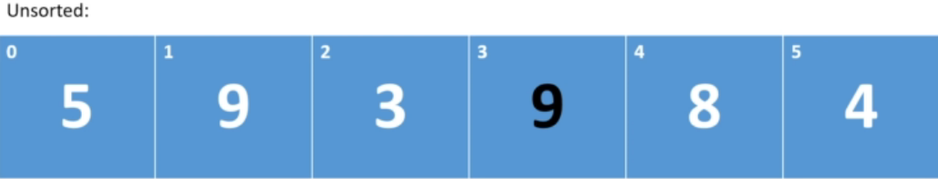  
* The question is: when we sort this array, will the original ordering of the two 9 be preserved?  
* In other words, in the sorted array, will the white 9 still come before the black 9?  
**Unstable Sort** => **the relative ordering of duplicate items won’t be preserved**.  
* In the Unstable Sort, the black 9 will end up coming before the white 9.  
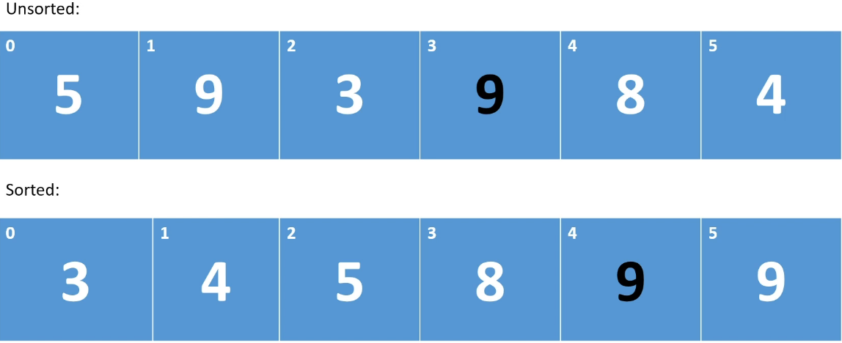  
* The array is sorted but the two 9 have flipped position. Their relative ordering has not been preserved.  
=> When this happens, when the relative ordering of duplicate items is not preserved when you sort, it’s considered to be an Unstable Sort.  
**Stable Sort** => **the relative ordering of duplicate items will be preserved**.  
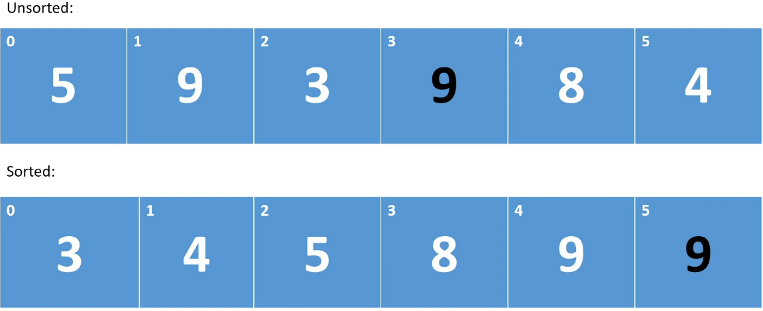  
* **A Stable Sort is preferable**.  
* For integers it doesn’t really matter but if you’re sorting objects, it could make a difference depending on how you’re using it.  
* **For example if you want to do a sort within a sort, so for example you may first sort based on name and then you want to sort based on age or something, well if the second sort causes the positions you got from the first sort to flip, that’s going to be a problem**.  
* So in some situations it will matter.  
* And so as we go through and look at the sort algorithms, we’ll think about whether they’re Stable or Unstable.  
=> **Bubble** **Sort** => **Stable** **Sort** **Algorithm**.  
* Because when we’re comparing adjacent elements, we only swap them if the element at i is greater than the element at i + 1. And so when the two 9 end up next to each other, we don’t swap.  
* If the algorithm or implementation said >= then we would swap them and it would be Unstable.  
* You don’t want to turn a Stable Sort into an Unstable Sort. And it’s really easy to do.  
* And I have seen cases around the Internet in blog posts and things like that where a Stable Sort algorithm has been coded to be Unstable. That little = in comparison can make a big difference.  
* So be aware of this when you’re reading code on the internet and when writing your own code.  
* Make sure that if a Sort Algorithm is Stable, that your implementation isn’t inadvertently changing it to an Unstable algorithm.

**Selection Sort (Theory)**  
* This algorithm **divides the array into sorted and unsorted partitions** just like Bubble Sort.  
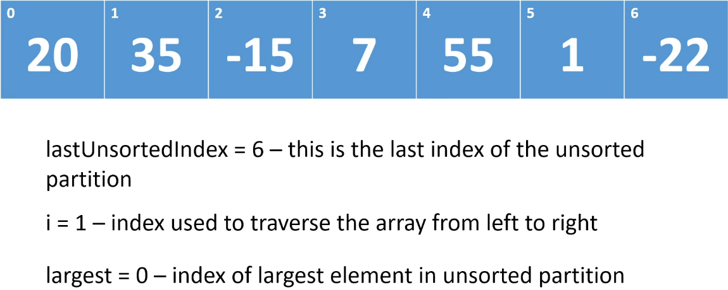  
* **We traverse the array and we look for the largest element in the unsorted partition**.  
=> **When we find it,** **we swap it with the last element in the unsorted partition**.  
* At that point, **that swapped element will be in its correct sorted position**.  
* And so just like with Bubble Sort, at the beginning the entire array is unsorted and we’re going to grow the sorted partition from right to left.  
* We’re going to initialize the largest field to the element at index 0 and then we’re going to start comparing the element at position 1 to the element at position 0 and we’re going to eventually find the largest element.  
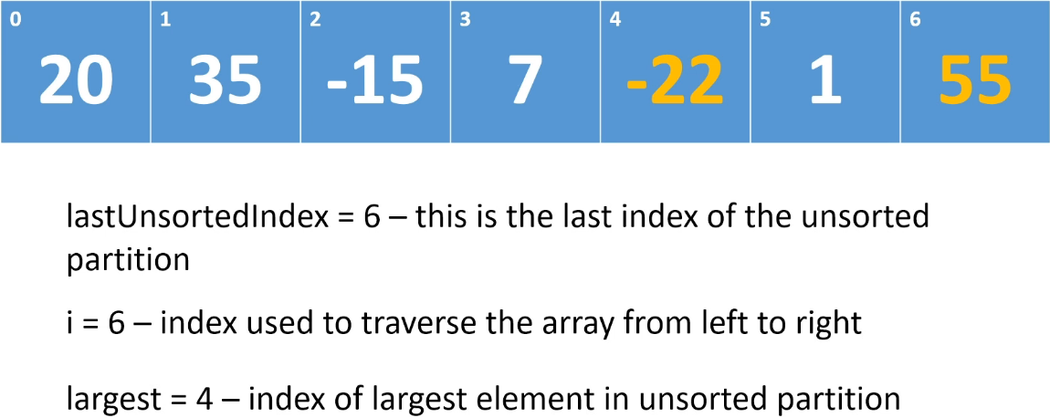  
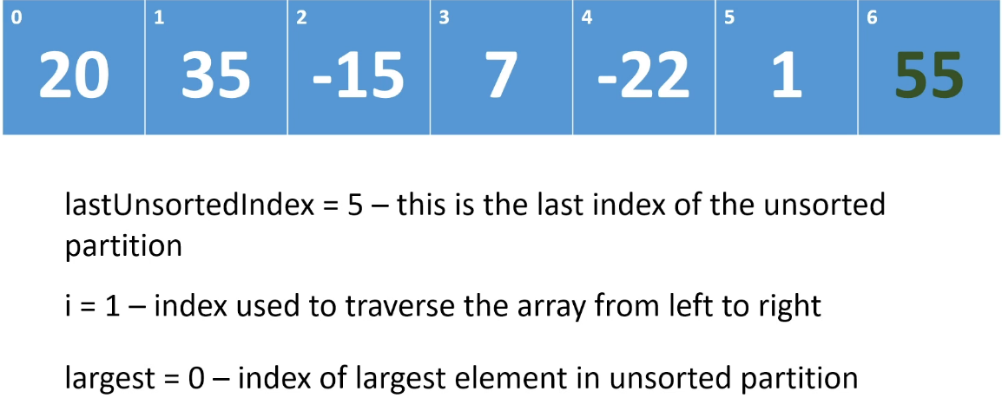  
* It’s called a Selection Sort because on each traversal, we’re selecting the largest element and we’re moving it into the sorted partition.  
**In-place  
Unstable**  
* **We only swap 1 per traversal so Selection Sort will usually perform better than Bubble Sort**.  
* However, it’s an Unstable algorithm because if we have duplicate elements, there’s no guarantee that their original order relataive to each other will be preserved because on each pass, **we swap the largest element with whatever is occupying the last position in the unsorted partition**.  
=> **And so it’s very possible that we could take the second duplicate value and move it in front of its twin**.  
* So if you need a Stable Sort algorithm, then you don’t want to be using Selection Sort.

**Selection Sort (Implementation)**  
**(Implemented my own version before watching this video)**  
* Unlike with Bubble Sort, we do need to check the element in the last position because here we want to compare every element against whatever’s largest so we need to compare the last element as well.  
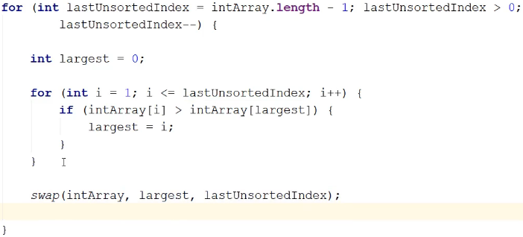  
* That’s Selection Sort, on each traversal of the array, it selects the largest value and it adds it into the sorted partition.

**Insertion Sort (Theory)**  
* **It again partitions the array into sorted and unsorted partitions**.  
* **This time the implementation I’m going to show you grows the sorted partition from left to right**.  
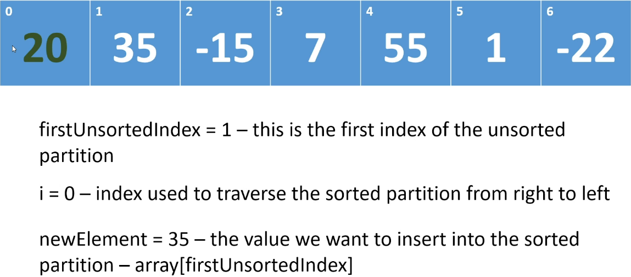  
* So it grows the sorted partition from the front of the array.  
=> It starts out by saying that the element at position 0 is in the sorted partition.  
=> Because this sorted partition is of length 1, by default the element is sorted.  
=> At the beginning the elements from position 1 and to the right are in the unsorted partition.  
=> So we’re going to set the first unsorted index field to 1.  
=> On each iteration, we take the 1st element in the unsorted partition, which will be the element at array of firstUnsortedIndex and we insert it into the sorted partition and so at the end of each iteration, we will have grown this sorted partition by one.  
=> We compare the value we’re inserting with the values in the sorted partition and we traverse the sorted partition from right to left and we look for a value that is <= to the one we’re trying to insert.  
=> Once we find that value, we can stop looking, we have found the correct insertion position for the new value that we’re trying to insert because remember when we’re inserting the value, we’re working within the sorted partition.  
=> And so if the element at index i in the sorted partition is <= to the element we’re trying to insert, then all of the values to the left of element i are will be <= to the value we’re trying to insert, because all the values are in sorted order.  
=> So as we look for the correct insertion position, we shift values in the sorted partition to the right.  
* At the end of the first iteration, the first 2 elements will be sorted.  
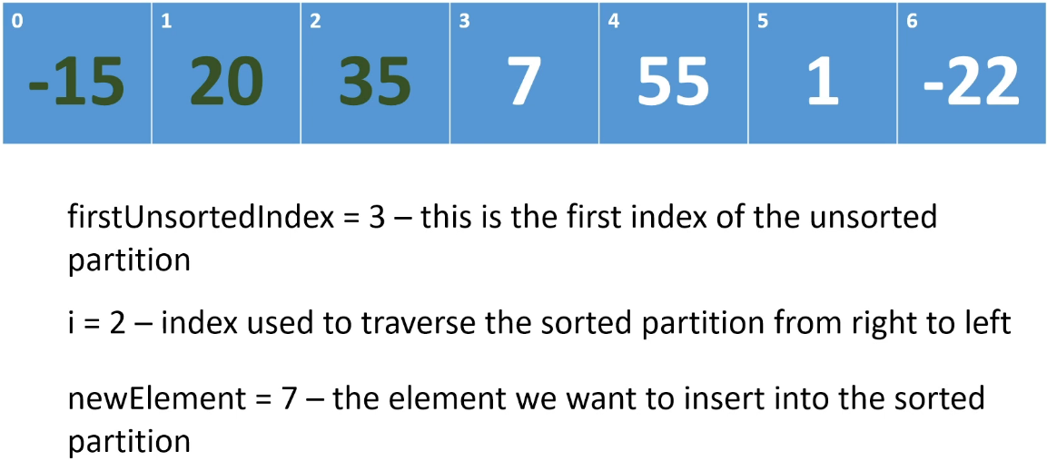  
* So that’s Insertion Sort. Our implementation starts by saying **the first element is sorted**. It grows the **sorted partition from left to right**. On each iteration, **it picks off the first element in the unsorted partition and it inserts it into the correct position in the sorted partition (stops comparing when the element in the sorted partition is <= our current element or when it reaches the start of the array)**. It does that by shifting elements to the right to make room for the new element.  
**In-place  
Stable**   
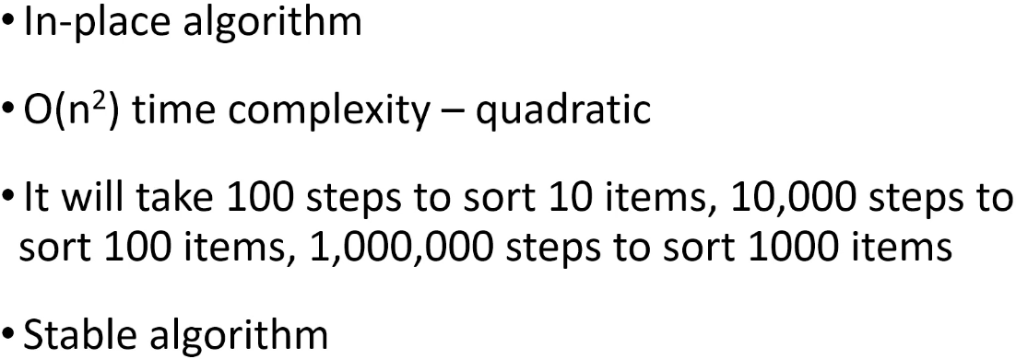  
* It’s Stable because when we’re picking off elements, we’re doing that from left to right. Let’s say there are two 9 in the array. We’re going to insert the left-most 9 first and then when we come to the right-most 9, when we’re looking for the insertion position, we stop when we hit an element that is <= to the one we’re inserting. So we’re eventually going to hit the first 9 and the second 9 will be inserted to the right of the first 9. And so the relative positions of those two 9 will be preserved.

**Insertion Sort (Implementation)**  
**(Implemented my own version before watching this video)**  
* This implementation doesn’t need the swap method.  
=> **We don’t swap, we shift elements**.  
* We want to keep looking for the insertion position as long as we haven’t hit the front of the array because if we hit the front of the array, it means that the element we’re trying to insert is the smallest element we’ve seen so far and the correct insertion position is 0. And we want to keep looking as long as the element we’re looking at in the sorted partition is > than the one we’re trying to insert because if the element at i - 1 is > than the element we’re trying to insert, then we still haven’t found the correct insertion position. So the moment we hit the front of the array, or the moment we hit an element that is <= the element we’re trying to insert, we have found the correct insertion position.

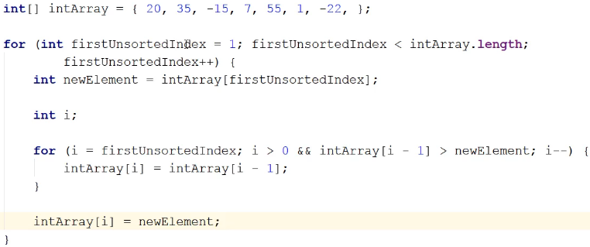  
* As you can imagine, sometimes this will involve a lot of shifting.  
* For example in our array the smallest value in the array is right at the end of the array. So when we hit the -22, we’re going to have to shift every element in the array to the right to make room for -22.  
* **This algorithm can be improved, we’re going to look at that in the next video**.

**Shell Sort (Theory)**  
* If the sequence of values that we’re sorting is nearly sorted, then insertion sort runs in almost linear time. And it does that because it doesn’t have to do as much shifting.  
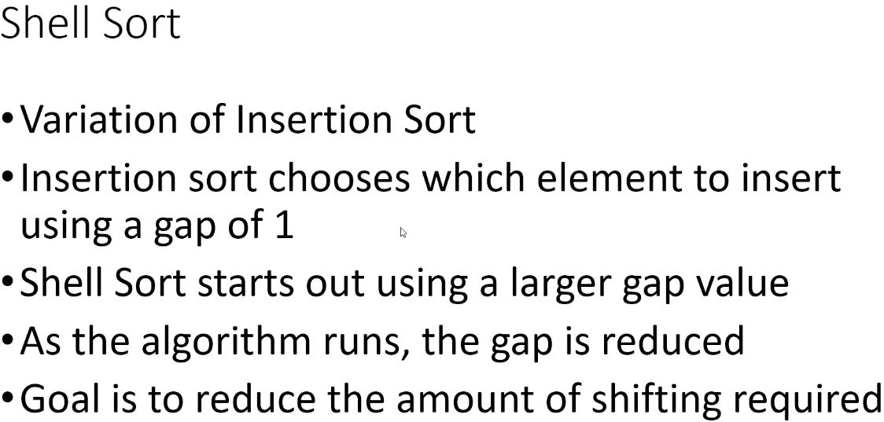  
* It’s a variation of Insertion Sort.  
* Insertion Sort chooses which element to insert using a gap value of 1.  
=> So every time Insertion Sort runs, it picks off the first unsorted value and then it compares that value to its neighbor and it keeps shifting the neighbors to the right until it finds the correct insertion point for the element that it’s inserting.  
=> Shell Sort starts out using a large gap value. So instead of comparing elements to their neighbors, it compares elements that are farther apart from each other in the array. And then as the algorithm runs, it reduces the fap that it’s using.  
=> The goal is to reduce the amount of shifting that’s required.  
=> As the algorithm progresses, the gap value is reduced.  
=> Shell Sort traverses the array with a certain gap value and after it has done its first traversal with the initial gap value, it decreases the gap and it does it again.  
=> And it does this and this is very important - it keeps reducing the gap value intil the gap value is 1.  
=> When the gap value is 1, we’re essentially doing an Insertion Sort.  
=> So the last iteration of the gap value will actually perform an Insertion Sort.  
=> But at that point, the array will be more sorted than it was at the beginning.  
=> And so essentially what Shell Sort does is it does some preliminary work, using gap values that are > 1 and that preliminary work puts the elements in the array perhaps closer to their sorted positions and then at the very last iteration when the gap value becomes 1, it does an Insertion Sort.  
=> That final Insertion Sort will be working with values that have had some preliminary sorting done on them. Because of that there will be a lot less shifting required.  
  
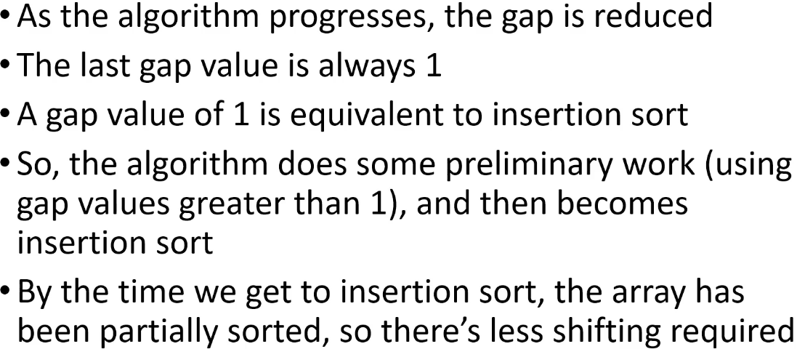  
<https://en.wikipedia.org/wiki/Shellsort>  
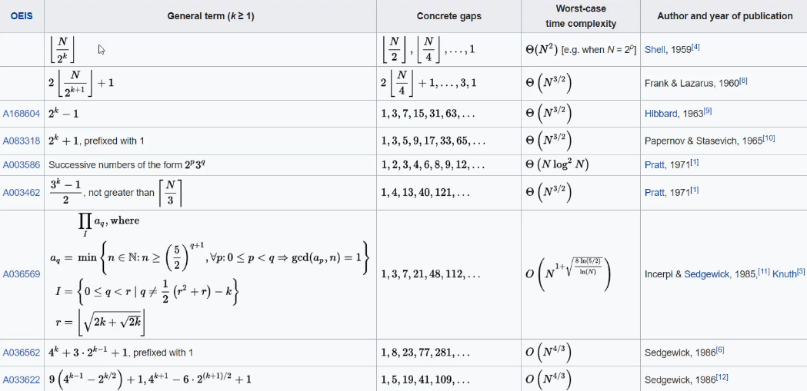  
* Here’s a table with different initial gap values and how to reduce the gap, what sequence of gap values to use.  
* The important thing to note is that the way that you calculate the gap can influence the time complexity. So the gap value you choose can influence how many steps the algorithm requires.  
* **The gap value is also called the interval**.  
* One really common sequence is used for the gap value is the Knuth sequence.  
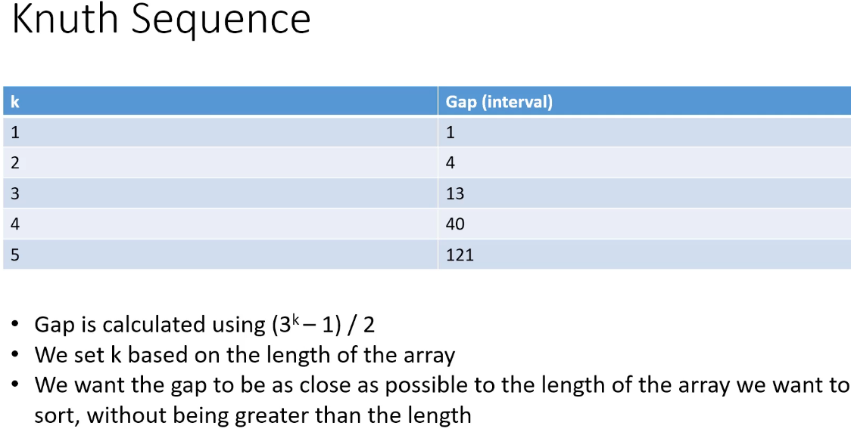  
=> We calculate the gap using (3 to the k minus 1) over 2  
=> The initial value that we want to use is based on the length of the array.  
=> What we want is to use the value of K that’s going to calculate to a value that’s as close as possible to the length of the array, without going over.  
* So if we had an array of 20 elements, we would want to start with K = 3.  
* When you want to use this sequence, you want to start with the value of K that’s going to result in a gap value that is as close to the array’s length as possible without going over.  
* In the implementation that I’m going to show you, we’re not going to use this sequence but it’s a common way of calculating the interval or the gap so I thought I’d show it to you.  
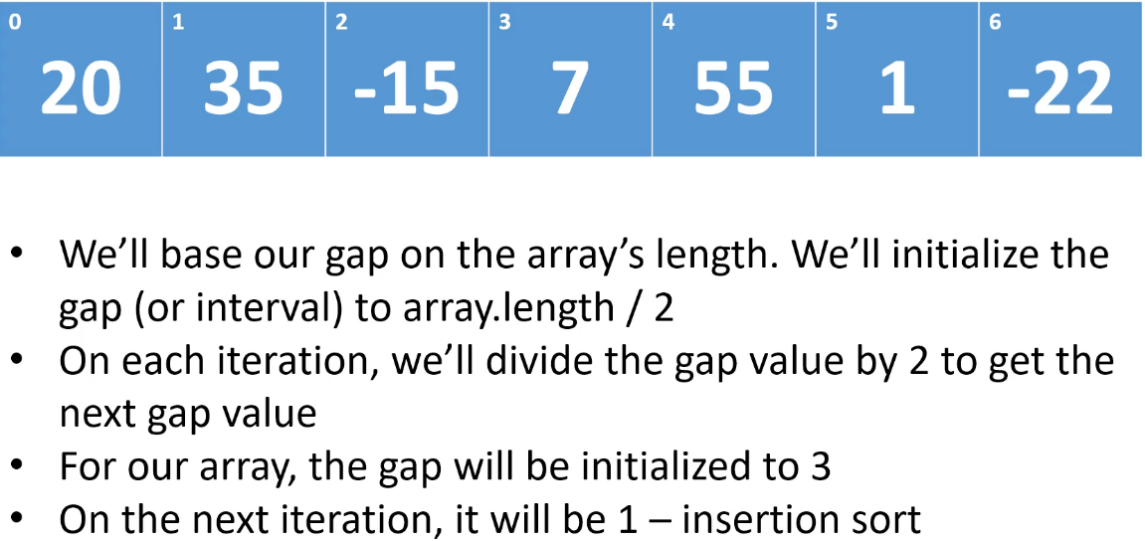  
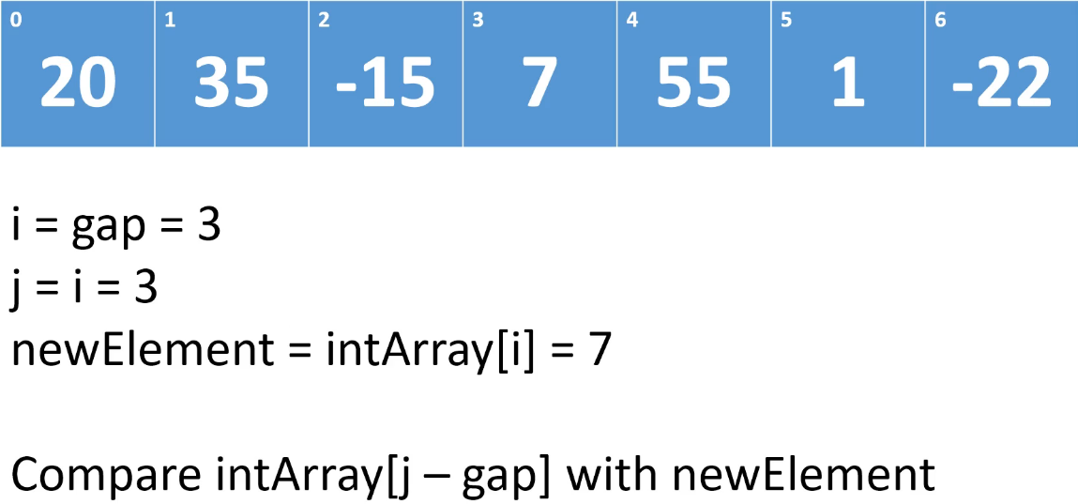  
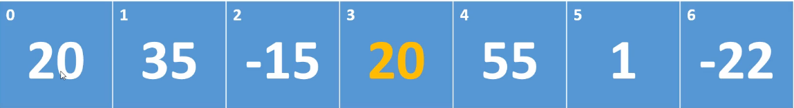  
* And then we set:  
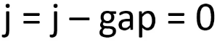 => we’ve hit the front of the array at this point and so what we’re going to do is assign newElement to position 0.  
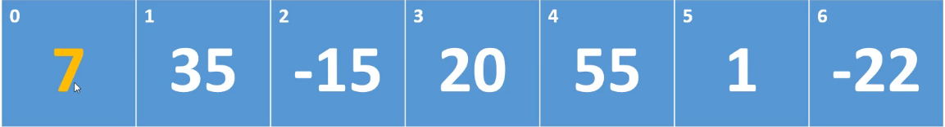  
=> So instead of comparing to the neighbors and shifting up one, we’re comparing using a gap of 3 and we shift by 3.  
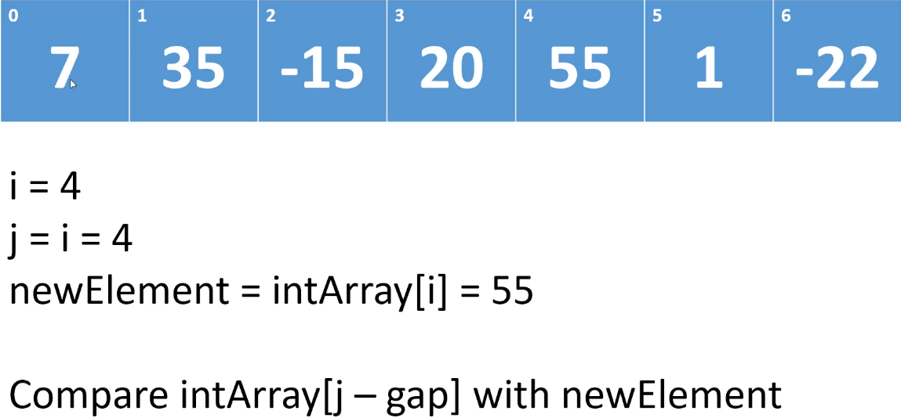  
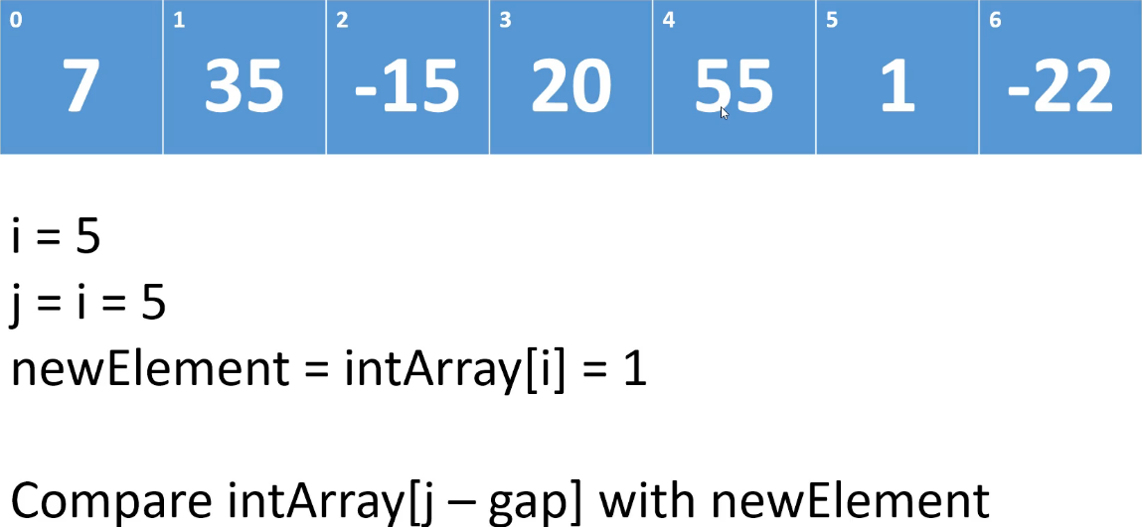

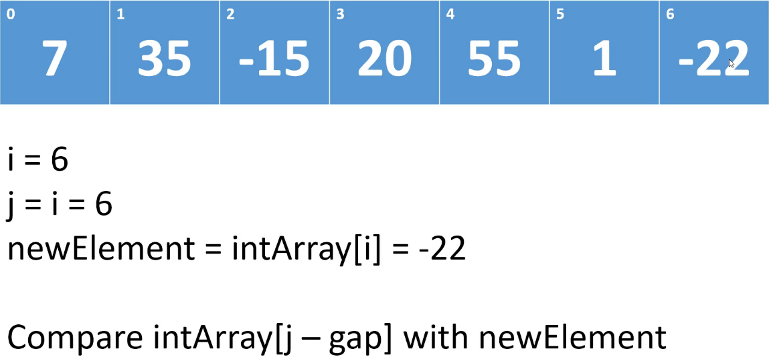  
=> We compare -22 with what’s at position 3 because 6 - 3 = 3.  
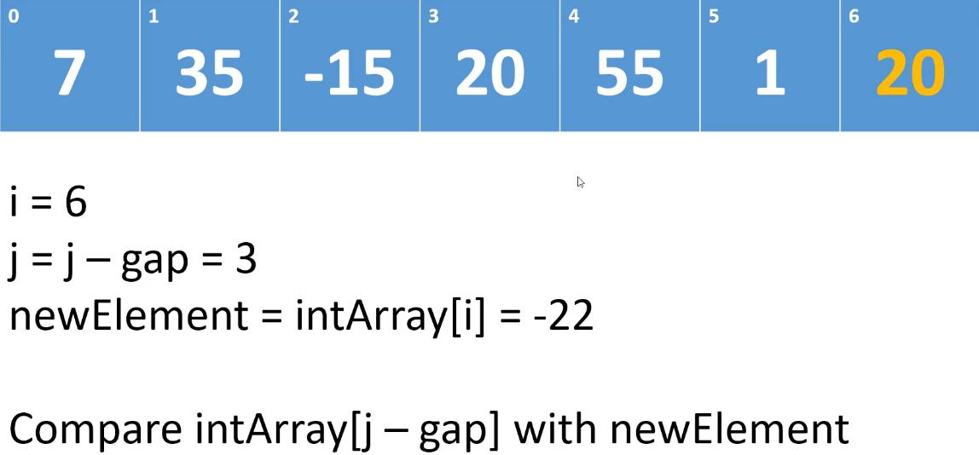  
=> We compare -22 with what’s at position 0 because 3 - 3 = 0.  
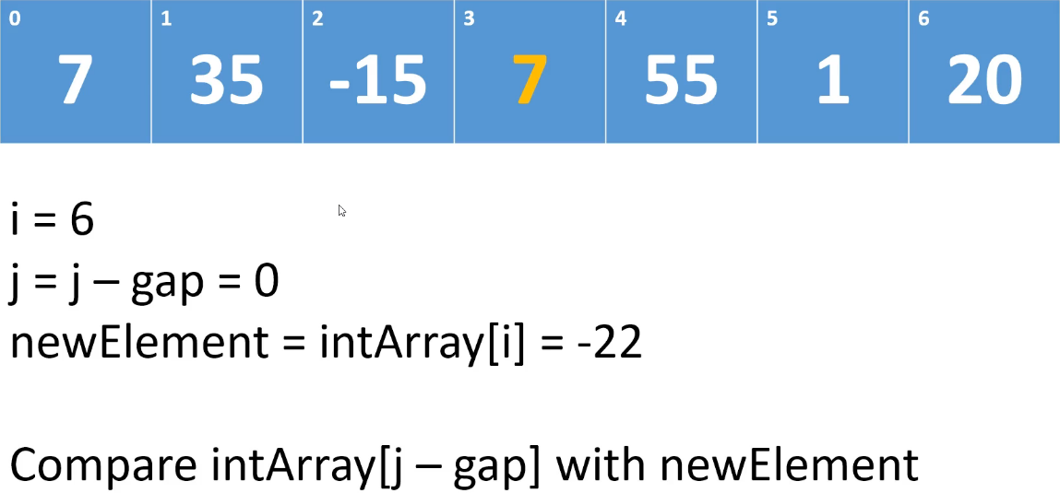  
=> At this point we’ve hit the front of the array, there are no more elements to compare -22 against.  
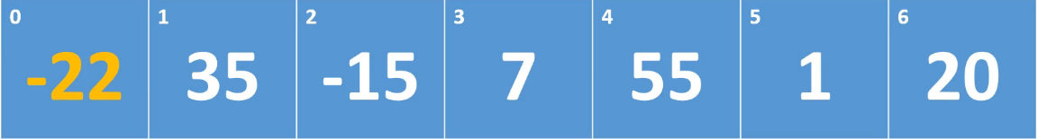  
* At this point we’ve also hit the end of the array and so we have finished our first iteration with   
gap = 3.  
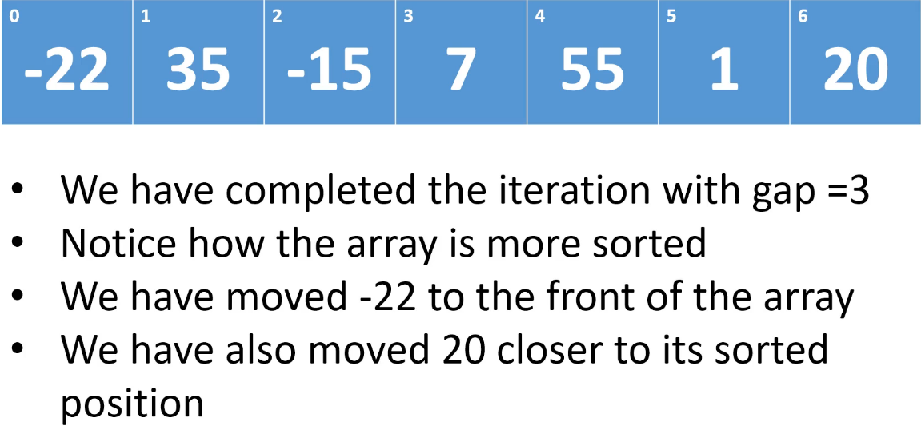  
* So in the implementation of Insertion Sort that I showed you, at some point we would have had to have shifted the -22 down, every single element would have to have been shifted up to make room for -22.  
=> But in this sort of pre-sorting phase, when we’re using a gap of 3, the -22 was moved very quickly down to the front of the array. We’ve also moved 20 closer to its sorted position.  
* You can see how doing this preliminary work before we get to Insertion Sort, will cut down on how much shifting we have to do.  
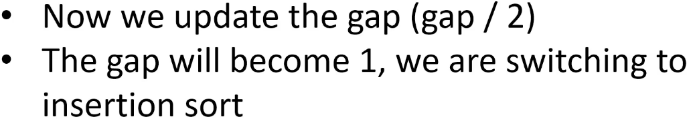  
=> 3 / 2 = 1 so at this point, we will do an Insertion Sort so we’re going to be comparing everything to its neighbors and when we shift, we’re going to be shifting up by 1.  
* So we’ll do an Insertion Sort but we’re doing it on an array that has had some preliminary work done on it so there’s going to be a lot less shifting.  
* That’s what Shell Sort is all about.  
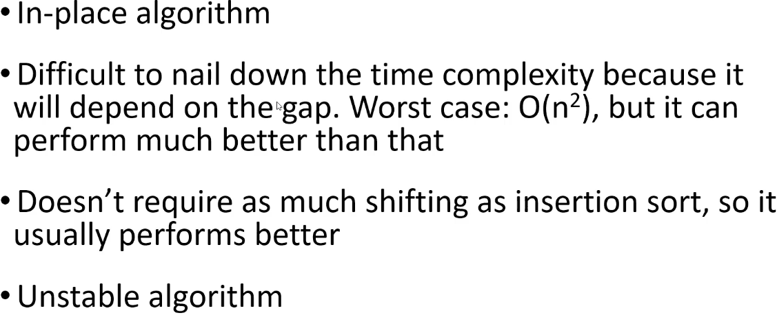  
**In-place  
Unstable**  
* It’s really difficult to nail down the time complexity because it’s going to depend on the gap. It’s going to depend on the method that you’re using to choose the gap.  
* **Insertion Sort is Stable, Shell Sort is Unstable**.  
=> It’s because in the pre-insertion sort phase when we’re comparing elements that are far away from each other, it’s very possible that if we have a duplicate element, the right-most element will be shifted in front of the left-most element. So the fact that we’re examining elements that are farther away from each other can lead to the relative positions of duplicate items not being preserved.  
* You can also improve Bubble Sort using Shell Sort => it would be the same type of idea. You would use a gap interval. In Bubble Sort, we’re always comparing elements to their neighbors and then we’re swapping and bubbling elements up. So in Bubble Sort if we use a gap of 1, that means we compare it to the neighbors and everything gets swapped up 1 position, things get bubbled up. If we do some preliminary work, and in this case rather than just shifting elements, we’d actually swap them, we can improve Bubble Sort. So you can apply Shell Sort to Insertion Sort and Bubble Sort. With Bubble Sort you’d be cutting down on the number of swaps that you have to do.

**Shell Sort (Implementation)**  
**(Implemented my own version before watching this video)**  
* As you’ll see, what we’re going to code in the outer for loop is essentially Insertion Sort.  
* It’s going to look slightly different because it’s using gap but it’s essentially Insertion Sort.  
* while (j >= gap && intArray[j - gap] > newElement) because if j becomes < gap, that means that we’ve hit the front of the array. And we want to shift the element at intArray[j - gap] up gap positions.  
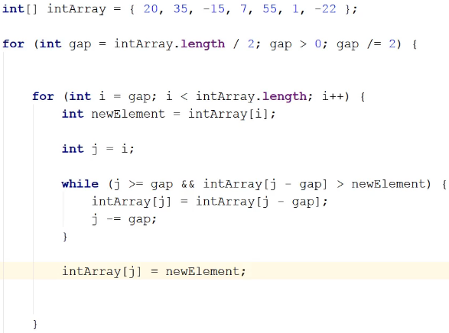

* Let’s compare our implementation of Shell Sort and Insertion Sort  
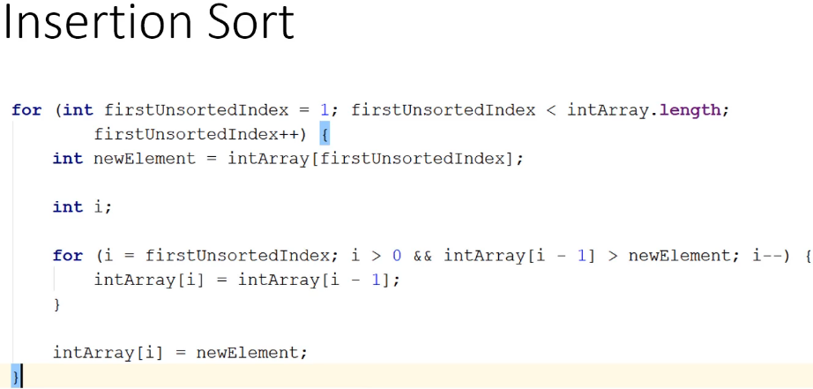  
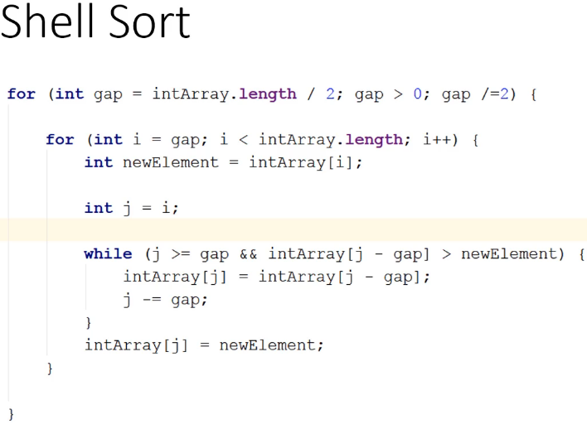  
* As I mentioned, you can also use the same idea to improve on Bubble Sort.  
=> You do some preliminary work.  
=> Instead of examining neighbors and swapping them, you’ll examine elements that are further apart and swap them if necessary.  
=> And so by the time you get down to the Bubble Sort where you’re using a gap of 1, there’ll be a lot less swapping to do.

**Recursion**  
**(Implemented my own version of factorial both recursive and iterative)**  
* The next couple algorithms that we’ll look at can be written recursively.  
* And they’re often written recursively.  
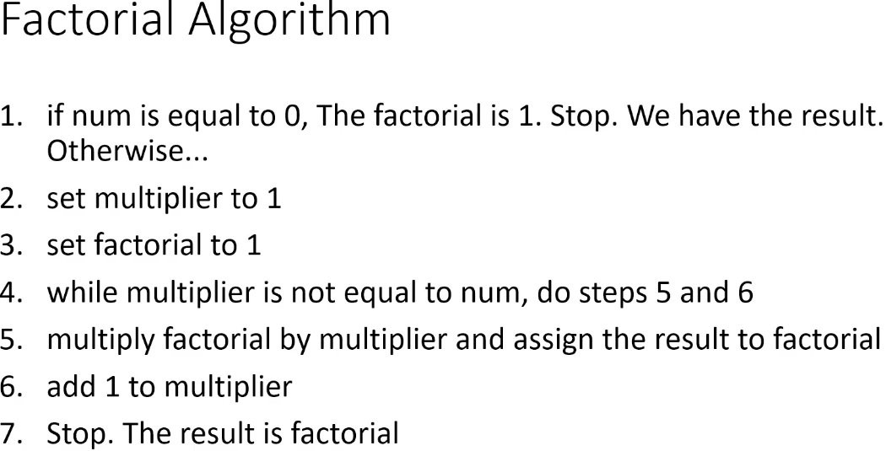  
* **A method is recursive if it calls itself**.  
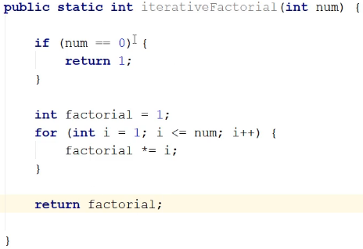  
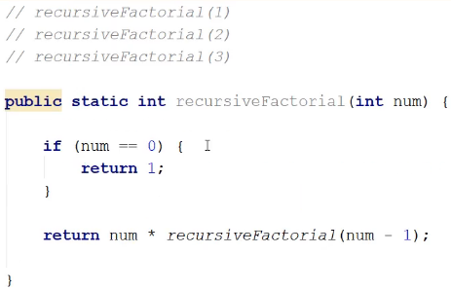  
* The order in which the recursive calls are made, they return in the reverse order.  
* Calling fact(4) => the first method that returns is fact(0) then fact(1)…  
=> So we return:  
fact(0) => 1  
fact(1) => 1 * 1 = 1 1 * 1  
fact(2) => 2 * 1 * 1 = 2 2 * 1  
fact(3) => 3 * 2 * 1 * 1 = 6 3 * 2  
fact(4) => 4 * 3 * 2 * 1 * 1 = 24 4 * 6  
* It’s important to see that when you enter a recursive method, it might be a while before it returns.  
* You can go down the rabbit hole and you can go deep.  
* So when you see recursion in the upcoming sort algorithms, keep in mind that the call to a recursive method may result in many more calls before it returns.  
* It’s important to understand that a 3-line recursive method could result in 100s of recursive calls.  
* The code might look simple but it can lead to a ton of processing.  
* And none of the recursive calls return until they receive the result from the method that they invoked recursively.  
**Breaking Condition / Base Case** => **In order for recursion to work properly, you need some condition that’s going to end the recursion**.  
* **The iterative implementation of factorial usually runs faster and it doesn’t use as much memory. Because there’s overhead involved with pushing method calls onto the call stack. And each stack frame uses some memory**.  
* But sometimes the iterative way isn’t as intuitive.  
* Or if you write the algorithm in an iterative way, it’ll be like 500-line method.  
* So developers still use recursion because it’s often the most elegant and easier to understand solution.  
* When dealing with the recursive method, the call stack can also be referred to as the **recursion stack**.

* It’s possible to get the StackOverflowError even when you do have a breaking condition if it keeps calling itself too many times.   
* There’s a way around this potential blowing of the stack, it’s called **Tail** **Recursion**.  
* **None of the algorithms / implementations we look at use tail recursion so we won’t look at it**.  
* **The Java Compiler doesn’t use Tail Recursion**.

**Merge Sort (Theory)**

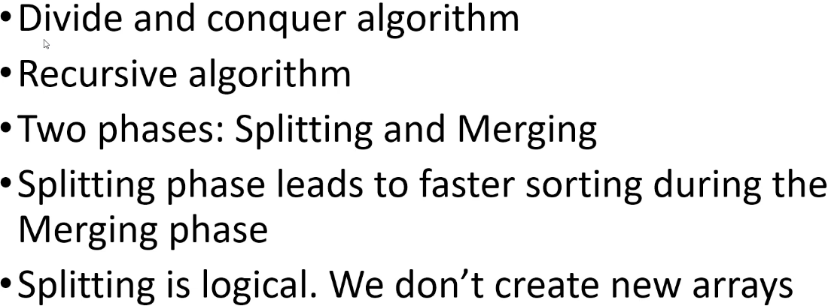

* **Divide and Conquer** algorithm  
=> Involves splitting the array you want to sort into a bunch of smaller arrays.  
* It’s usually implemented using recursion.  
**1) Phase** **=>** **Splitting => preparation phase, leads to faster sorting during the merging phase.**  
**2) Phase =>** **Merging => we do sorting during the merging phase.**  
* The splitting is **logical** => **we don’t create new arrays when we do the splitting**.  
=> We use indices to keep track of where the array has been split.

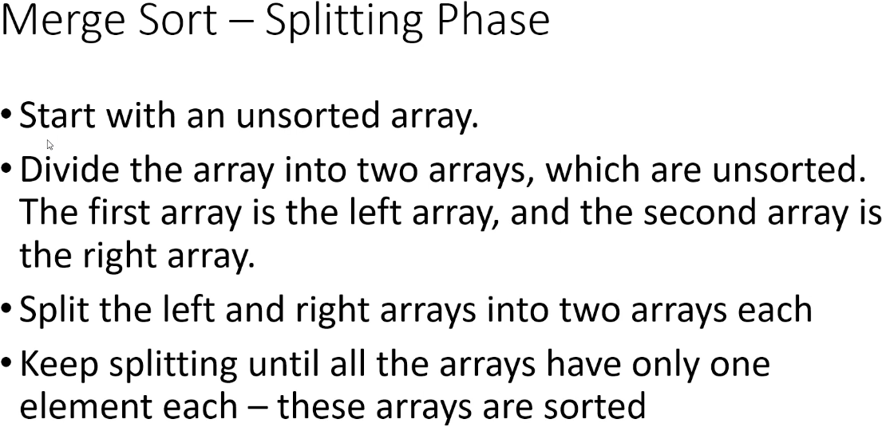

**In-place**  
* So in the splitting phase, you’re taking the array, you’re dividing it in half, and you keep doing it until you get down to a bunch of 1-element arrays, which are sorted by default.

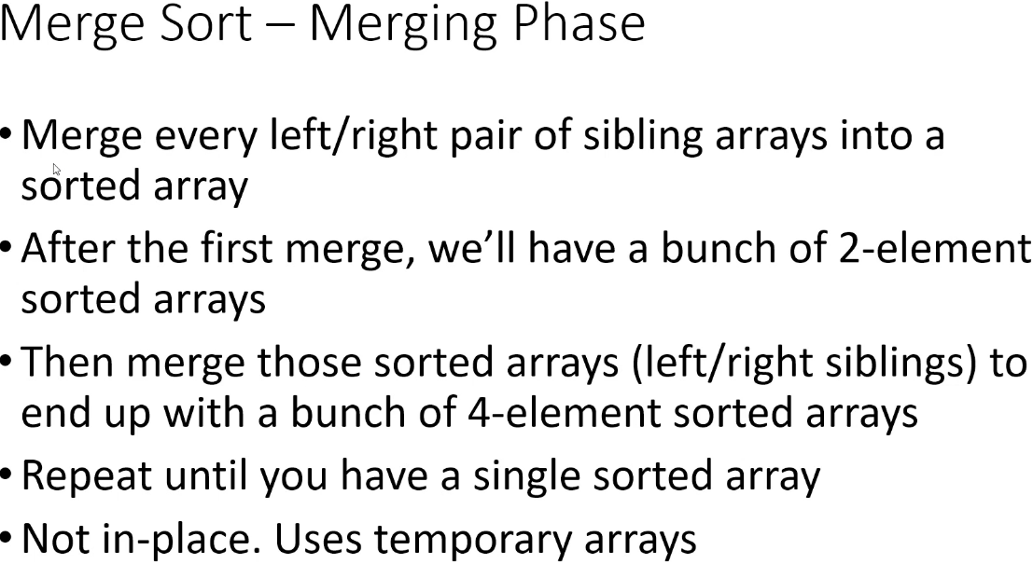

**Not in-place => uses temporary arrays**  
* 4 => 2 2 => 1 1 1 1 => sort 1 1 and 1 1 => sort 2 and 2 => sorted 4.  
* So we take a bunch of 1-element arrays and we keep merging them into 2-element, 4-element, 8-element, etc. and at each merge, we’re making sure that that the resulting arrays are sorted. Until we’ve merged all the arrays back into 1 array which will be sorted. Every resulting array from the merge will be sorted.  
* The merging phase doesn’t happen in place, we need temporary arrays.  
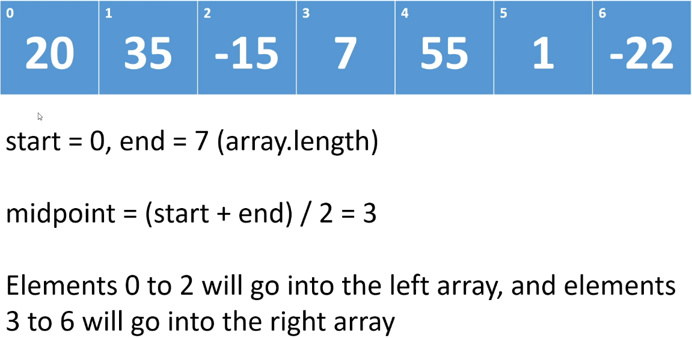  
* **In the implementataion I’m going to show you, the extra element will go into the right array**.  
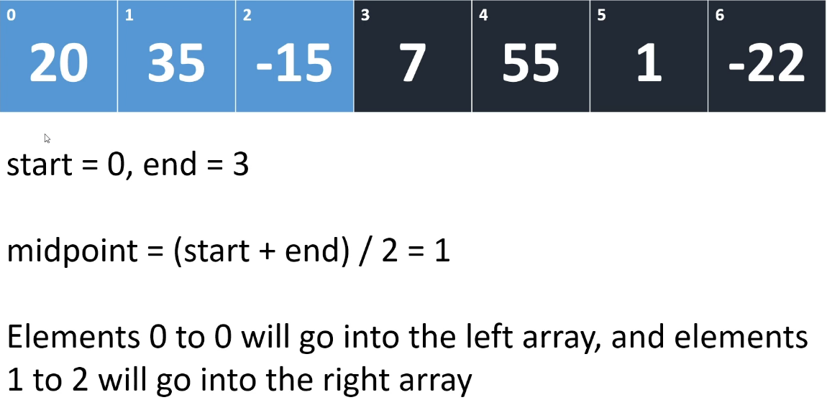

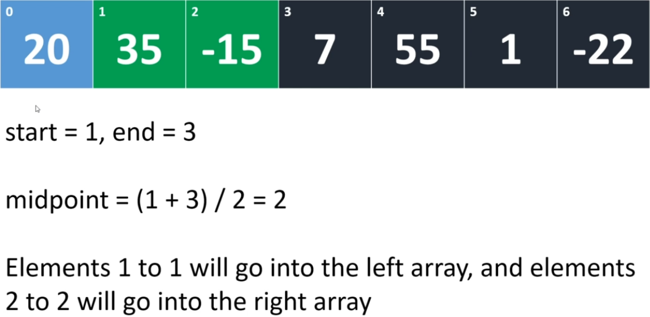

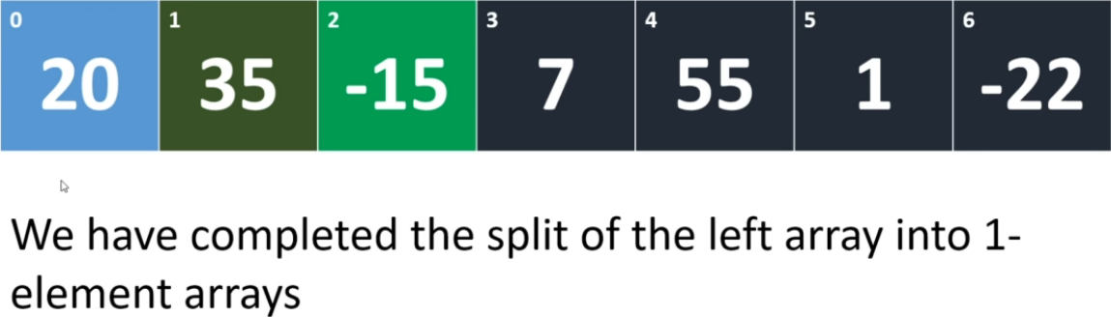  
* The first merge will be merging 35 with -15.  
=> **We’re always merging the last split**  
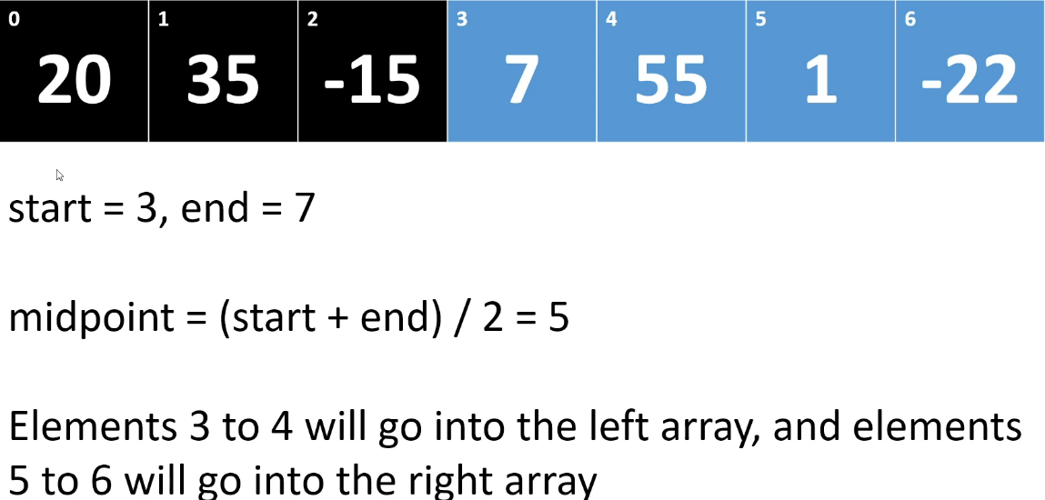

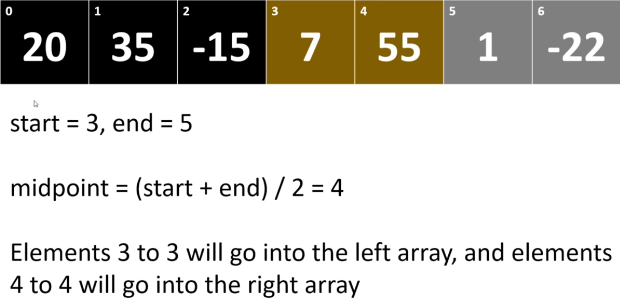

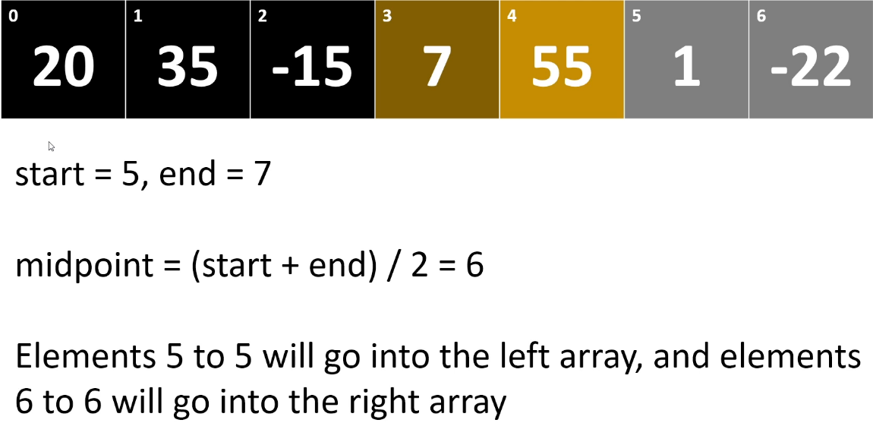

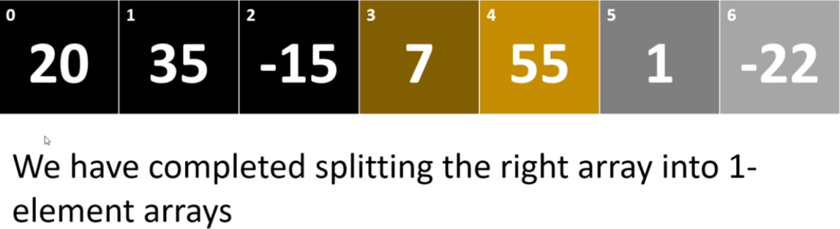  
* The similar colored ones are going to be merged together because they’re siblings.

* **Now we need to do the merge**.  
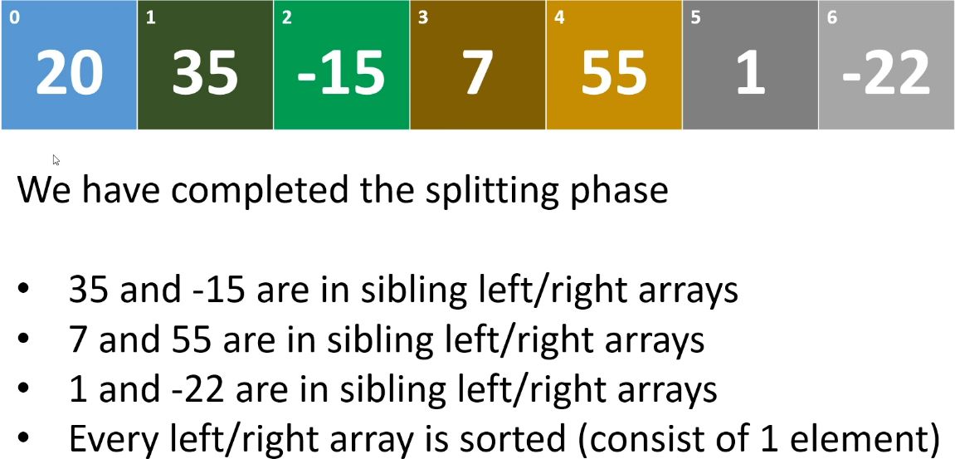

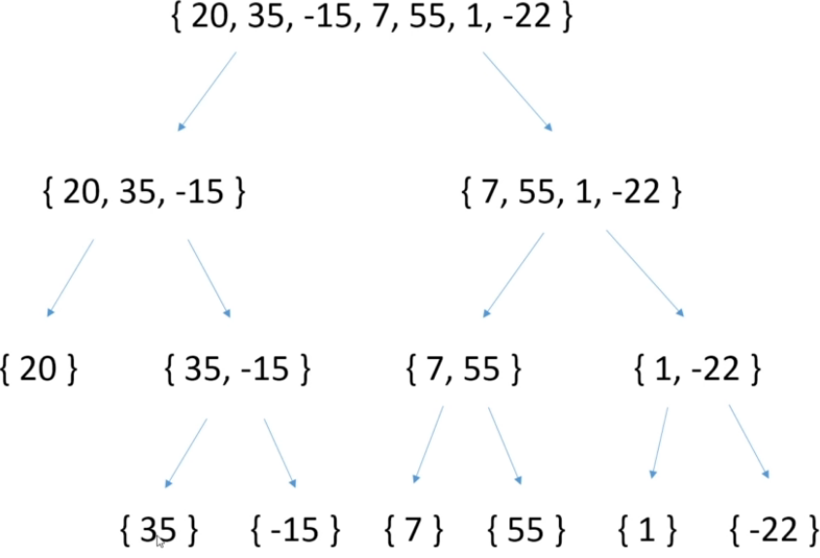

* Because of the recursive nature of the implementation, it’s important to note that we’re going to handle the entire left side of the array before we start working with the right side array.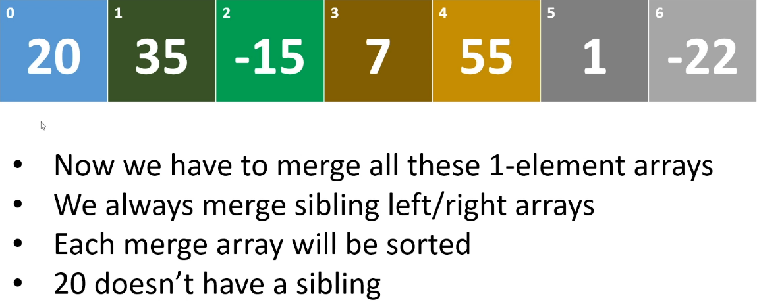

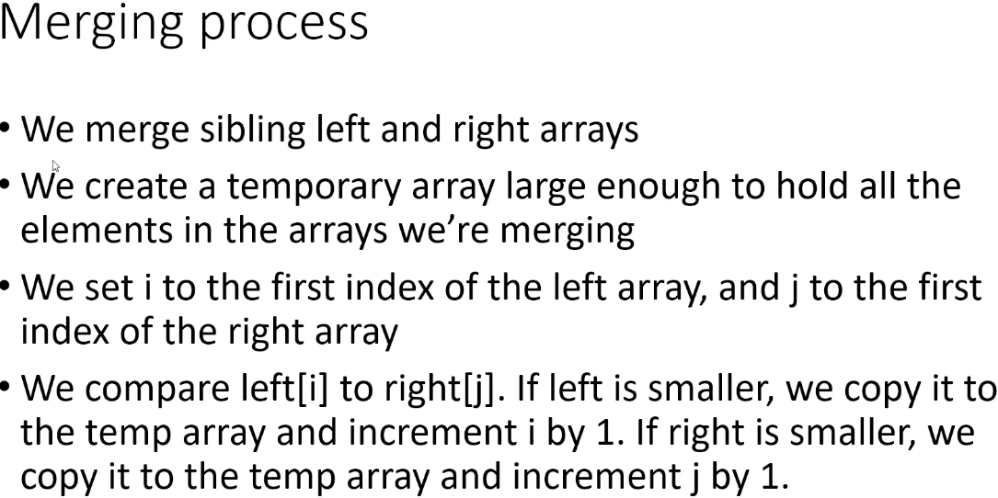

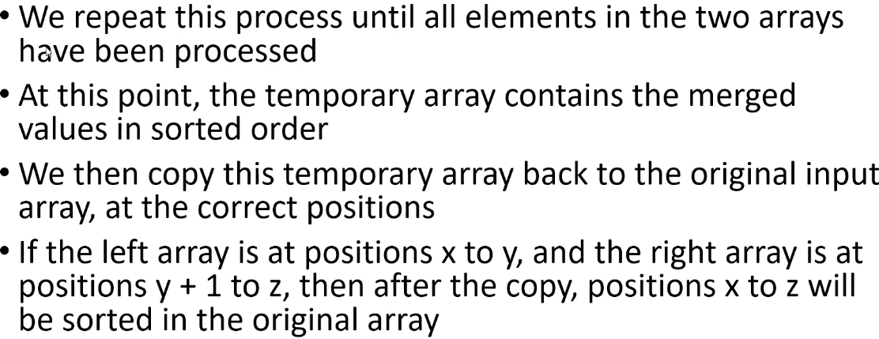

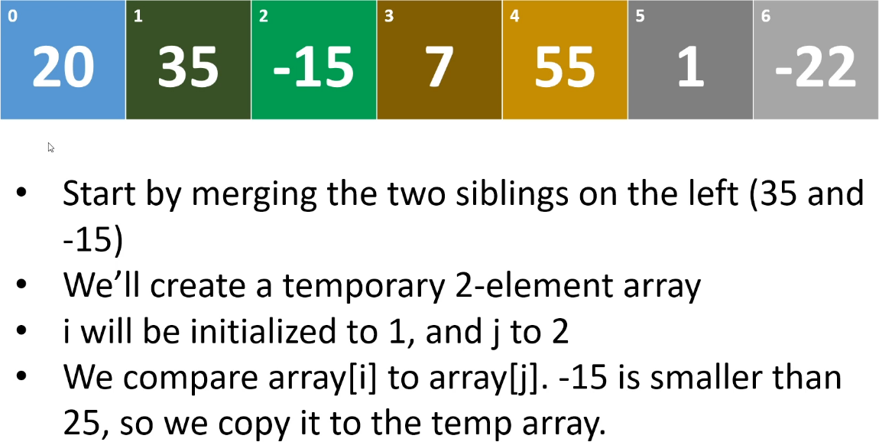  
(there’s a typo, that should be 35)  
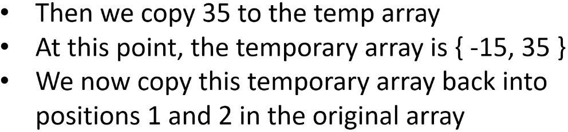

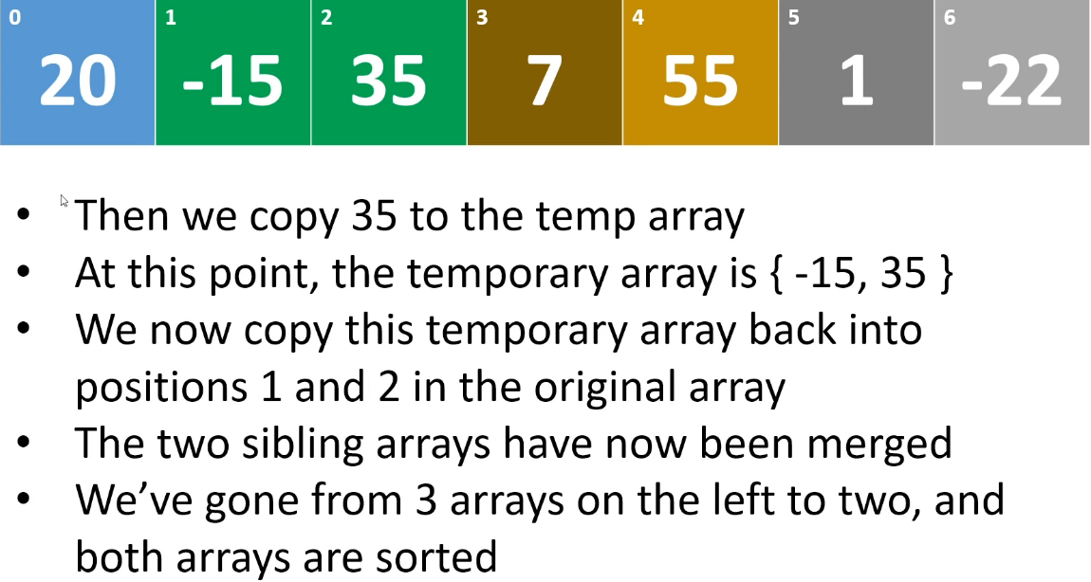

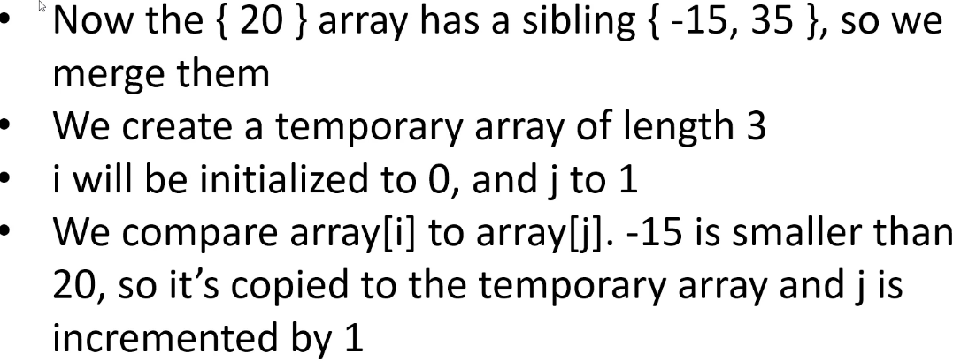

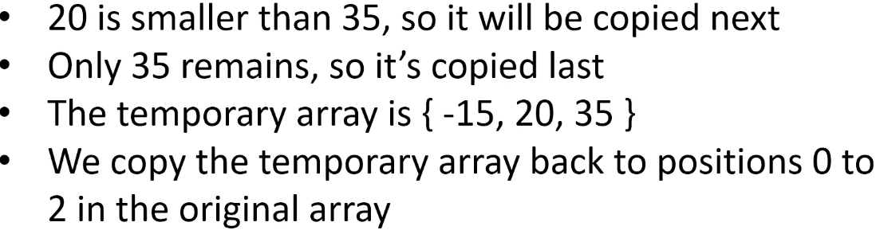

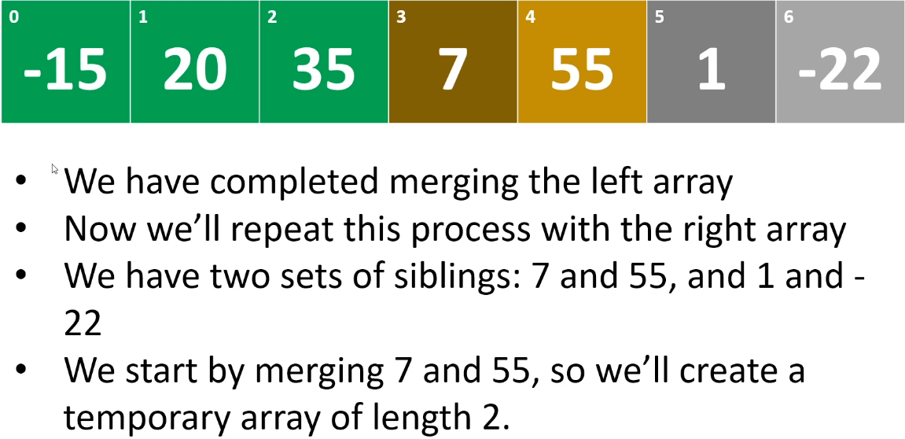

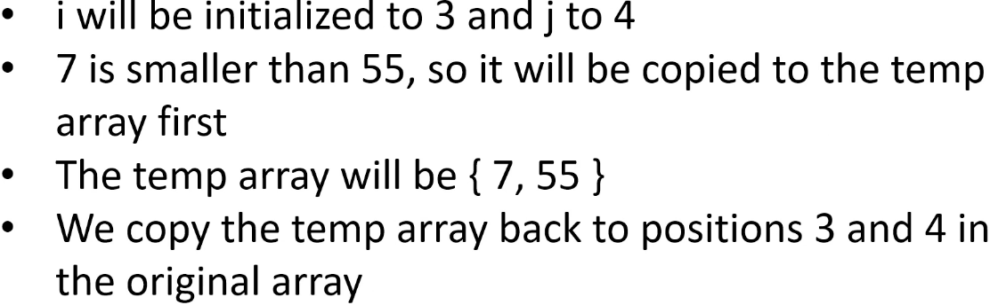

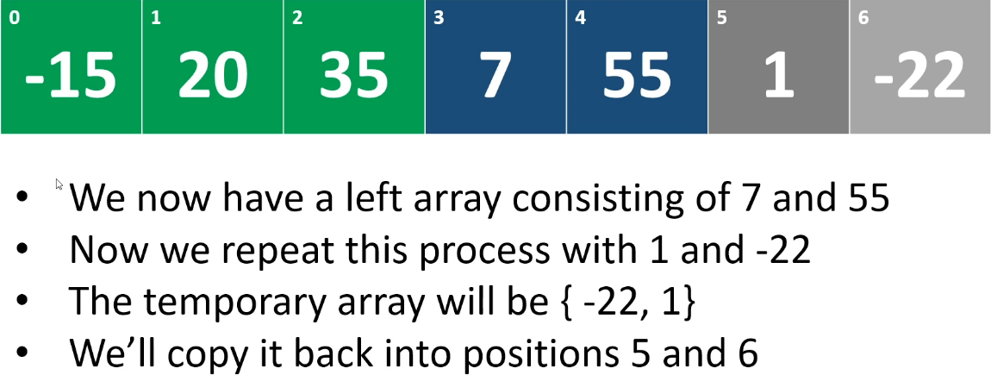

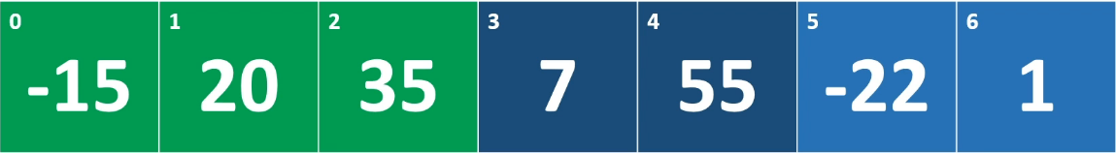  


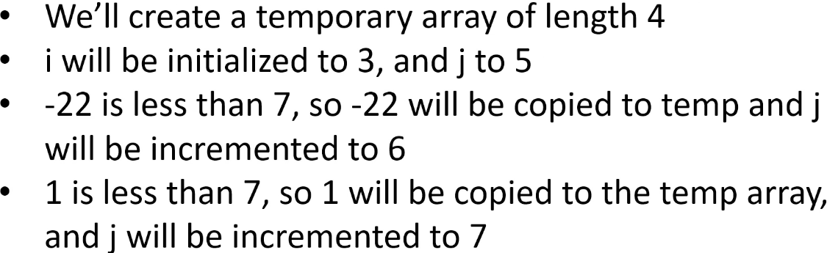

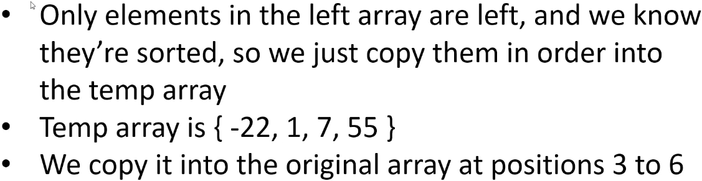

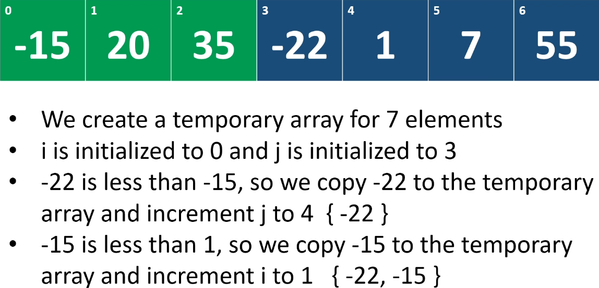

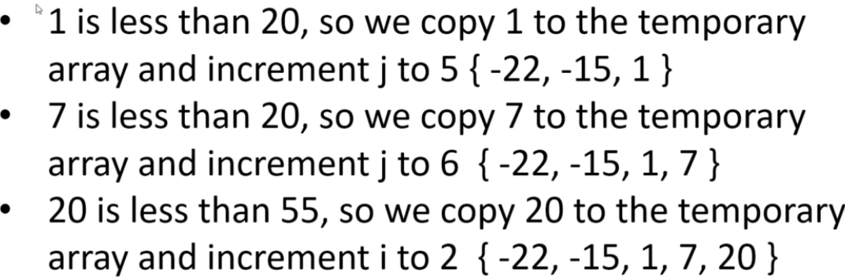

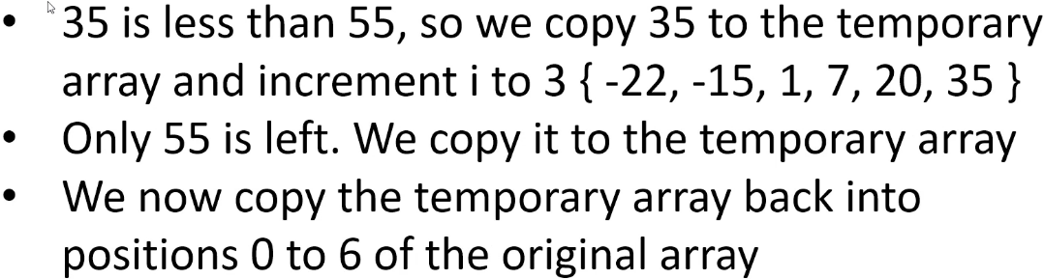

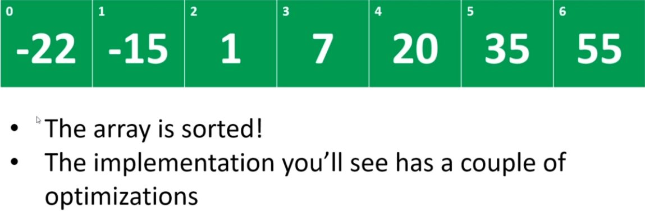

* It is quite a bit of work but because we’re dividing and conquering, we’re splitting the array into 2 at each phase, it actually performs better than the algorithms we’ve seen so far.  
**NOT in-place algorithm  
Stable => when we do the merging, we check whether the element in the right array is > than the element in the left array. If it’s equal, then the element in the left array will be the one that’s copied into the temporary array first and because of that, the relative ordering of duplicate items will be preserved.**  
**O(nlogn) - base 2 => we’re repeatedly dividing the array in 2 during the splitting phase**.

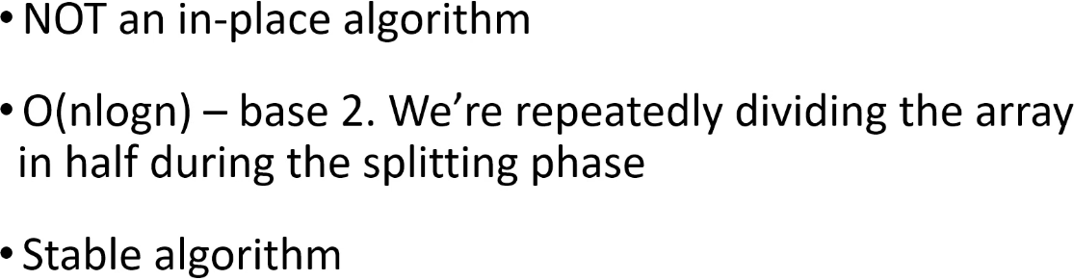

* The implementation I’m going to show you has a couple of optimizations, but it’s still Merge Sort and it’s still a logarithmic algorithm.  
* **These days memory is cheap and plentiful so the fact that it’s not an in-place algorithm shouldn’t dissuade you from using it**.   
* But **if memory is an issue, then that’s a consideration** because there’s a lot of temporary array instances created and of course the amount of memory you’re going to need is going to grow as the number of items you’re sorting grows.

**Merge Sort (Implementation)**  
**(Implemented my own version before watching this video)**  
* **The end is always 1 greater than the last valid index of the partition that we want to sort**.  
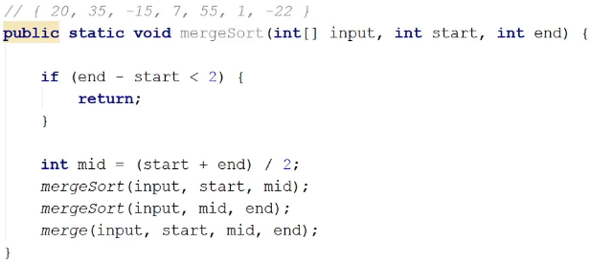  
* The implementation I’m going to show you has a couple of optimizations.  
* **Optimization 1: If input[mid - 1] <= input[mid] { return }**=> We’re always merging sorted arrays, so when we call merge, the left partition that we’re merging is sorted and the right partition is sorted.  
=> And we know that mid is the first element in the right side and it’s 1 greater than the last element in the left side.  
=> input[mid - 1] is the last elemenet in the left partition.  
=> input[mid] is the first element in the right partition.  
=> If the last element in the left partition is <= to first element in the right partition, that means all the elements in the left partition are <= to the smallest element in the right partition because both of those parts are sorted.  
=> If we were to go through the merge process with those sections, we would end up coyping the entire left array into the temporary array and then we would copy the entire right array into the temporary array. Because essentially because all the elements in the left array are smaller than the elements in the right array, to merge them we just need to stick them together. We just need to copy the left array and then the right array.  
=> But remember that after that, we would copy the merged array back into the original array, into the positions that are already occupied by these same elements and that means we’re not going to change the original array in any way because we’re just going to end up copying the elements back in the same order they’re already in.  
=> **None of the positions of the elements in the original array would change so it’s needless work**.  
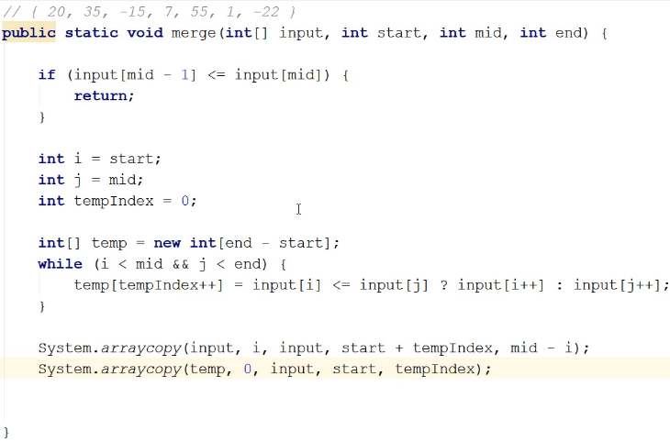  
* **Merge Sort is table, we have the input[i] <= input[j] then the left one goes into the temp**.  
=> **So the left will be written first and that’s how we preserve the relative ordering**.  
* When we drop out of this while loop, one of the partitions (subarrays) will have some elements left over that we haven’t copied into temp.  
* Optimization 2:   
=> Handling the remaining elements in the array that we haven’t traversed.  
=> If we have elements remaining in the left partition, we have to copy them into the temp array.  
=> **BUT if we have elements remaining in the right partition, we don’t have to do anything. It’s the same situation as with the first optimization**.  
=> Those elements would be > then everything currently in the temp and also they’re sorted already. So it would again be replacing the same elements in the original array. Its position would not change.  
* When we copy the remaining left elements in the left array over, we’re not actually going to copy them into temp because they’ll basically jump over all of the elements that we’ve copied so far and so we can just do that copy within the input array, we know the positions we need to copy to.  
**System.arraycopy()** => 1st parameter is the source array,   
 2nd parameter is at what position to start to copy and   
 3rd parameter is the destination array  
 4th parameter is to what index to copy, destination index  
 5th parameter is the length that we’re going to write  
=> i => if there are left over elements in the left array, this is the first index of the first element that we still haven’t handled.  
=> tempIndex => basically counted how many elements we’ve handled.  
* And so the destination position for any elements in the left array that are going to basically jump over all of the elements in the temporary array, is start + tempIndex.  
* So if we’re merging two 2-element arrays and we’ve copied 3 elements into the temp array and we have that 1 left over element in the left array, the left partition that we haven’t handled, then we’ll add 3 to the start index and so it’ll be copied into the original input array after the elements that we’re going to copy in from the temp array. So we don’t actually copy any left over elements in the left partition into the temp array. We just copy them directly into where they would end up in the input array.  
=> mid - i => the number of elements that we didn’t copy over into the temp array from the left partition. If we completely traversed the left array, this would end up being 0 and so we won’t actually do a copy here.  
* And if we didn’t completely traverse the right array, this arraycopy won’t do anything because this isn’t paying any attention to the j, it’s just handling the left array.  
* That’s Merge Sort, it’s doing a lot of work, it looks deceptively simple but as I said in the recursion video, 2 lines of code when you’re dealing with recursion code, can deal to hundreds of calls. So there can be a lot going on under the covers.

**Quick Sort (Theory)**  
**Divide and Conquer** algorithm  
**In-place** (**unlike Merge Sort**) => **we don’t have to create any temporary arrays**.  
**Unstable => because when we’re alternating between i and j, we’re swapping potentially things from the left to things to the right and things to the right over to the left, so we can have elements jumping over each other, there’s no guarantee that the relative positioning of duplicate items will be preserved.**  
**O(nlogn)** - **base 2** => **we’re repeatedly partitioning array into 2 halves**.  
**In the worst case, it’s actually a quadratic algorithm but in the average case, it performs with a time complexity of O(nlogn)** - **base 2** => **we’re repeatedly partitioning array into 2 halves**. **and most of the time it performs better than Merge Sort**.  
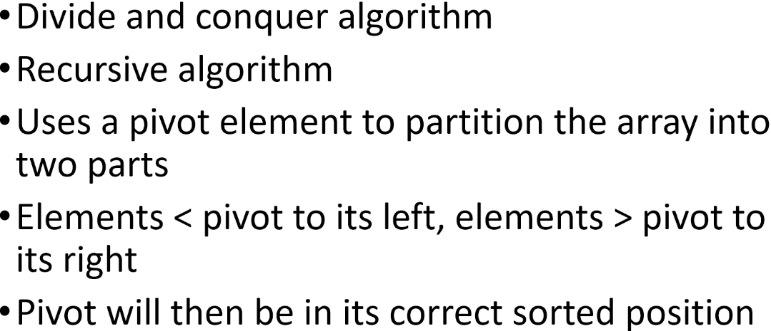  
* Can be written recursively and often is.  
* Quick Sort **chooses a pivot element and then it divides the array into 2 halves**.  
* **This division is a logical division so you don’t create new arrays, it’s happening in the original one**.  
* On the left half, it puts elements that are < pivot  
* On the right half, it puts elements that are > pivot  
=> **Partitioning Step**  
* So the pivot element will be in the middle, between the 2 arrays.  
=> **After we’ve finished the partitioning step, the pivot is in its correct sorted position**.  
=> BUT, and this is important to note, **the left/right subarrays aren’t necessarily sorted**.  
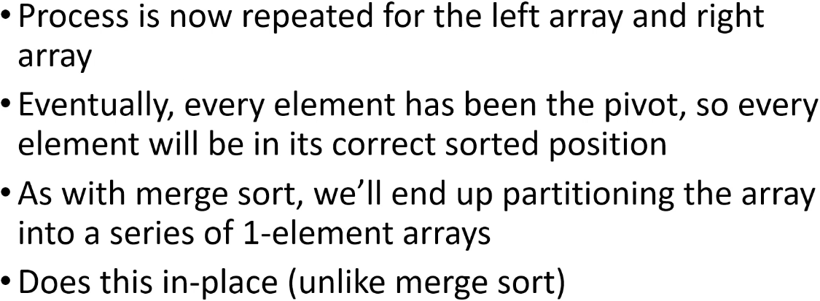  
* **We do the same with the left an right subarrays**.  
=> **Eventually, every element has been the pivot, so every element will be in its correct sorted position**.  
* One advantage of Quick Sort is that **you don’t need a lot of memory** to do this sort, unlike Merge.

* In the implementation that I’m going to show you, we’re always going to choose the 1st element in the array/subarray as the pivot.  
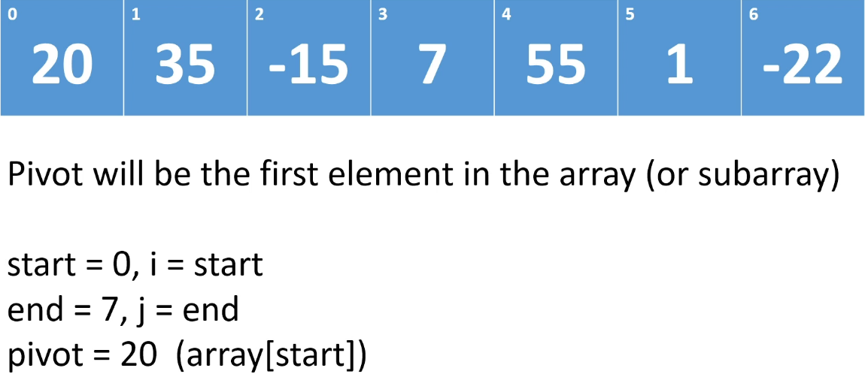

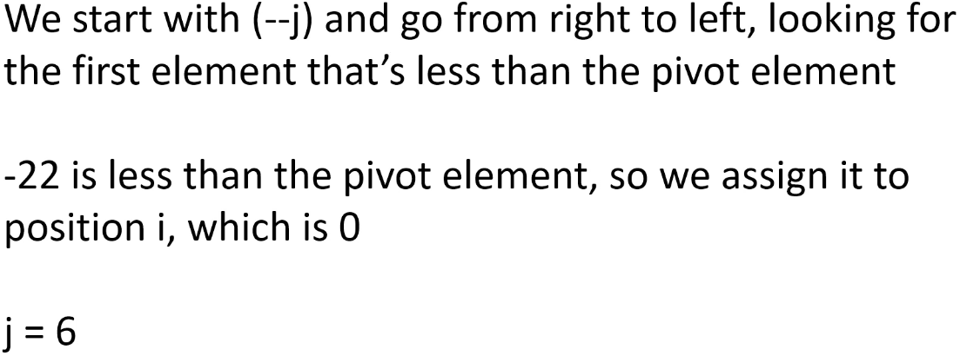

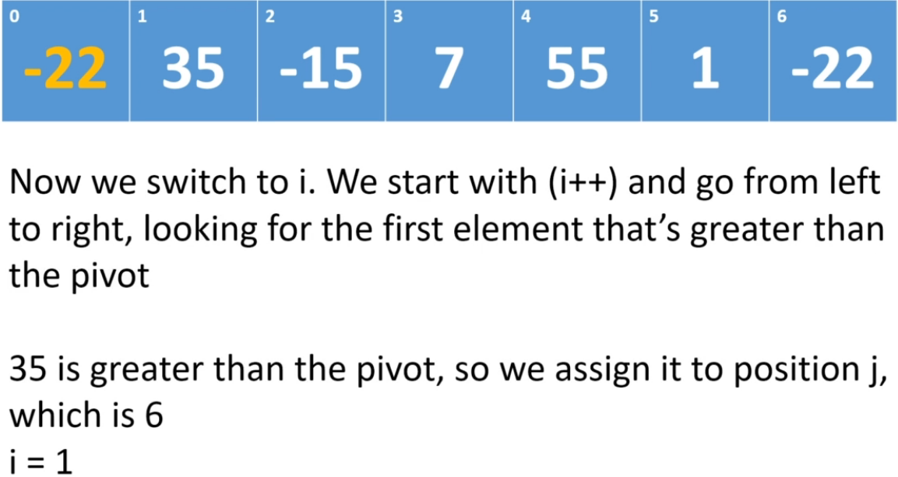

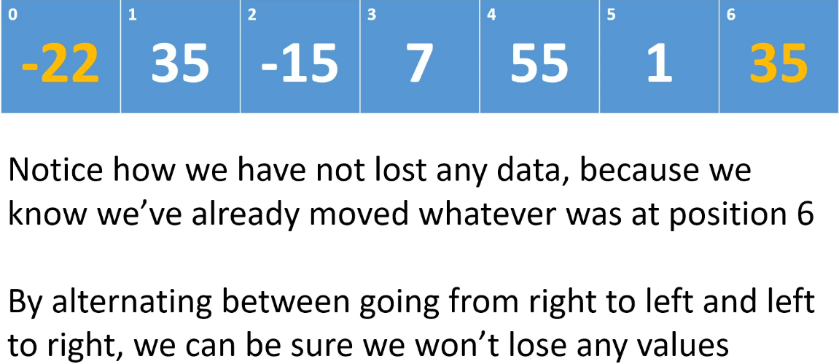

=> **By alternating between going from right to left and left to right, we can be sure we won’t lose any values**.

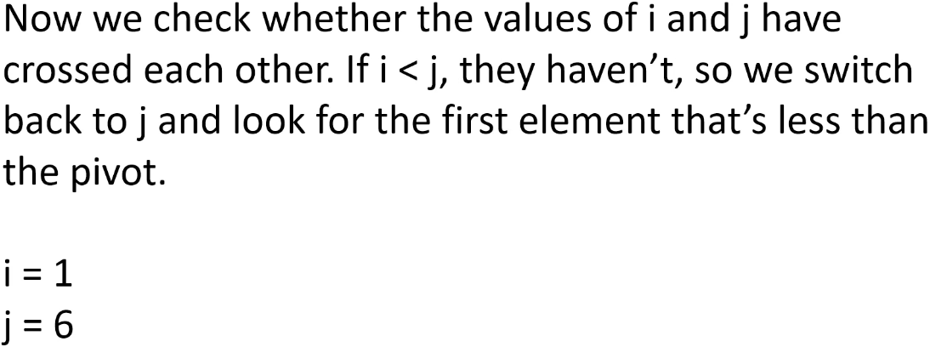

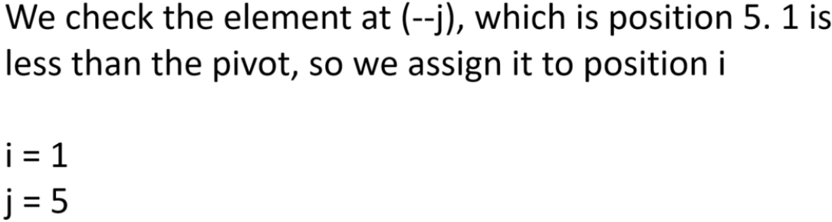

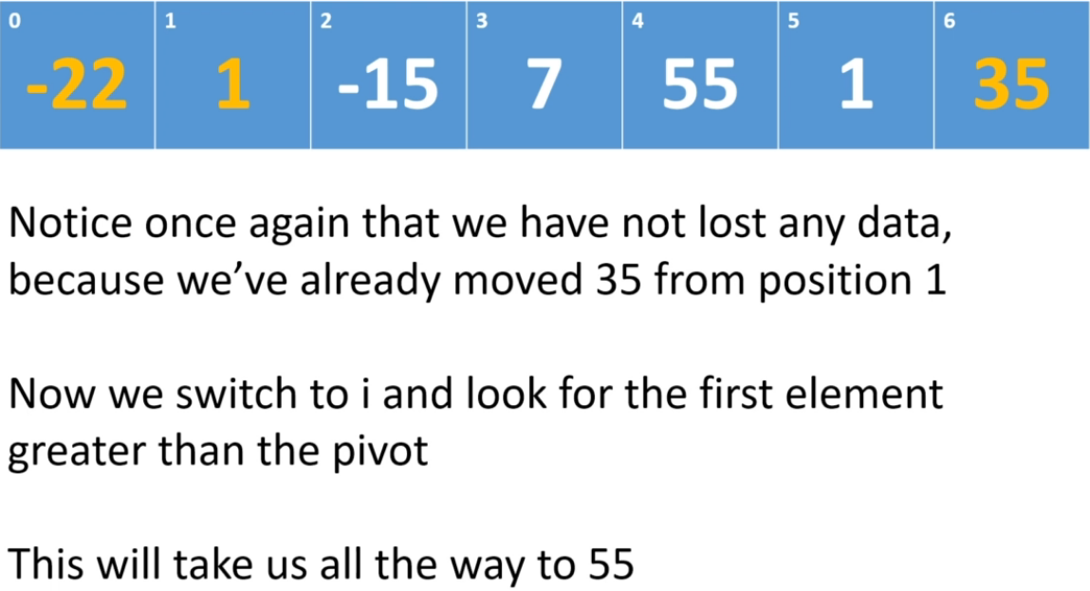



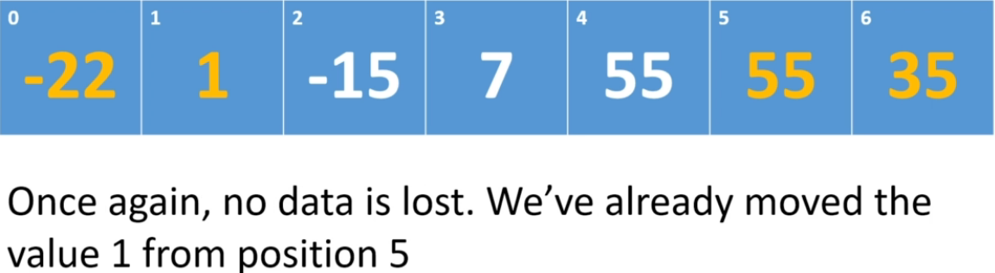

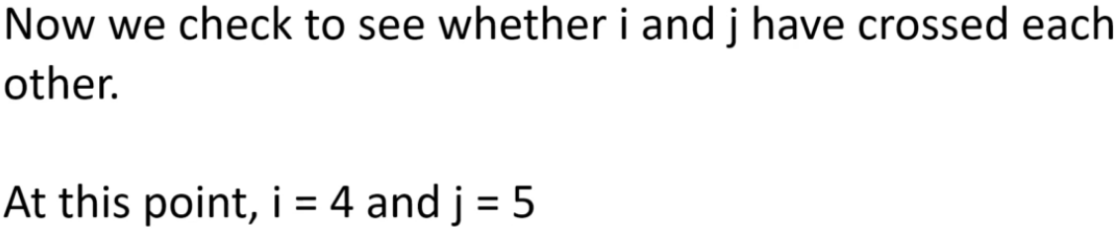

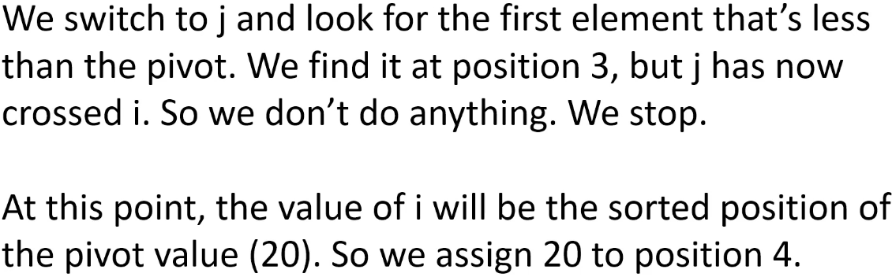

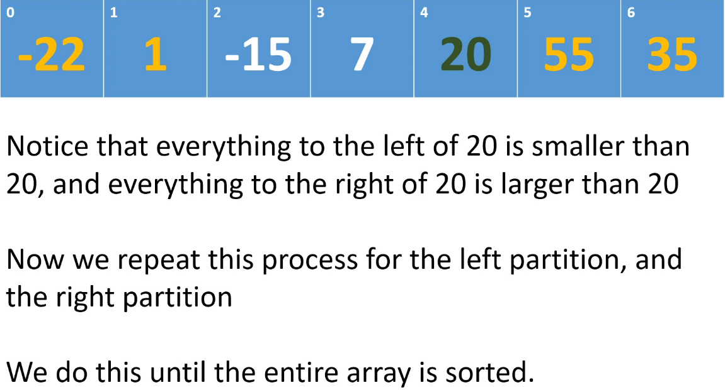  
* It’s important to note that **the choice of pivot can have an effect on the time complexity**.

**Quick Sort (Implementation)**  
**(Implemented my own version before watching this video)**  
* We’re going to code 2 methods: **quickSort()** and **partition()**.  
* The `end` will be 1 greater than the last valid index in the array.  
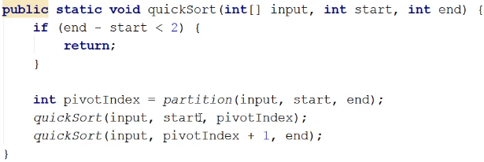

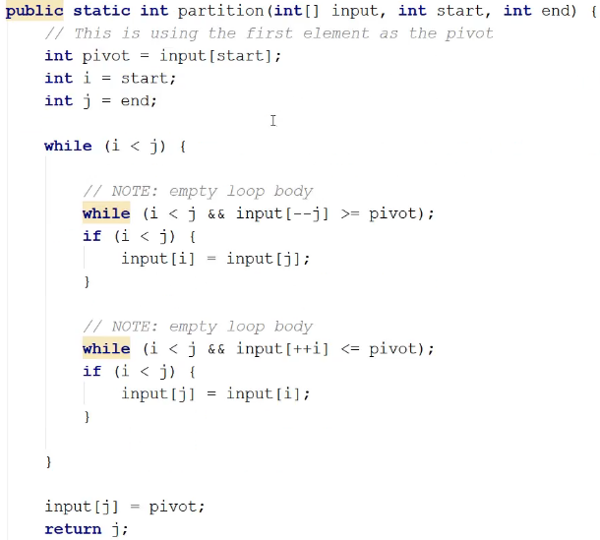  
* **We’re not doing anything within the body of the loop**, so we’re basically using the loop to keep **decrementing j until we either find an element that’s < pivot or j crossed i**.  
* It’s the fact that we’re alternating between i and j and which direction we’re traversing in that lets us do these types of assignments without losing any data.  
* Important: we’re using the prefix decrement and prefix increment - this means that when we execute this statement, we’ll decrement j and THEN we’ll use the result as the index.

**Counting Sort (Theory)**  
* **The algorithms we’ve looked at so far, don’t make any assumptions about the data they’re sorting**.  
=> We can sort integers, floats, strings, objects, anything.  
* The algorithms don’t assume a certain data type.  
* **Specific implementations do but not the algorithms themselves**.  
* They also don’t assume that the data being sorted is bound in any way.  
* For example, they don’t assume that all the values being sorted will be < 100.  
* There are algorithms that do make assumptions about the data being sorted and because they make assumptions, they can sort the data more efficiently.  
=> In fact, **they can achieve linear time O(n) complexity**.  
* The next couple algorithms we’re going to look at, make assumptions about the data.

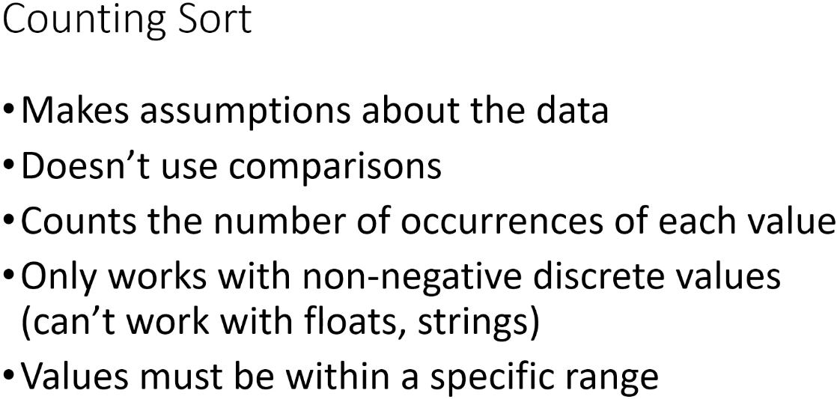

=> It assumes that all the values are discrete and they’re within a specific range.  
=> Only works with non-negative discrete values.  
=> Practically speaking, you’ll usually use this algorithm **with whole numbers**.  
* It doesn’t use comparisons, it doesn’t actually compare values in the array against each other.  
=> Instead, it counts the number of occurrences of each value  
* Values must be within a specific range and the range has to be reasonable, it can’t be huge.  
* You’re not going to use Counting Sort for numbers that are between 1 - 1 000 000 for example.  
* Our usual array is not a good candidate for Counting Sort, it has negative numbers, so we’re going to use a different array to go through this algorithm.  
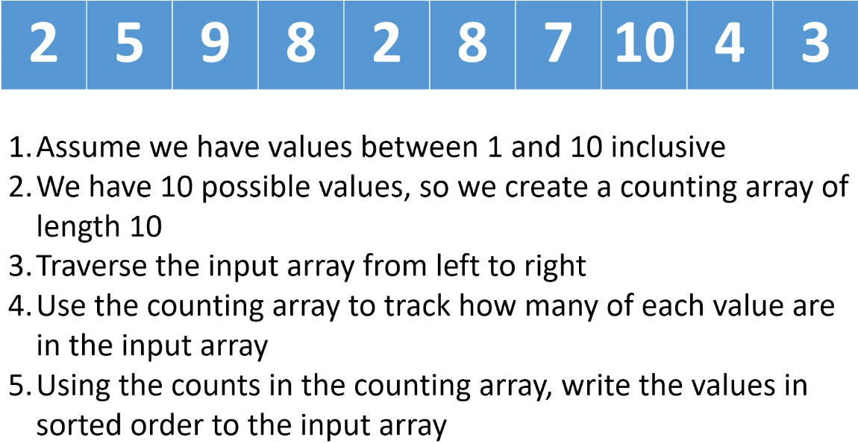  
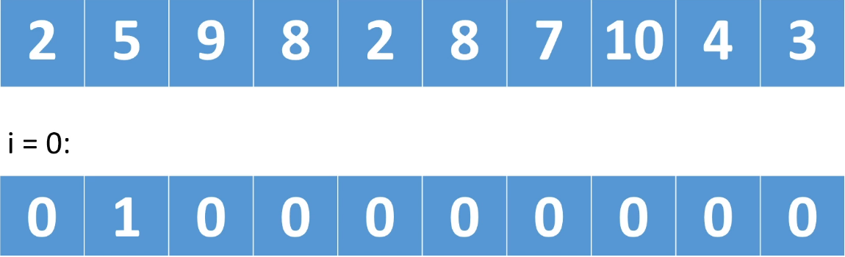  
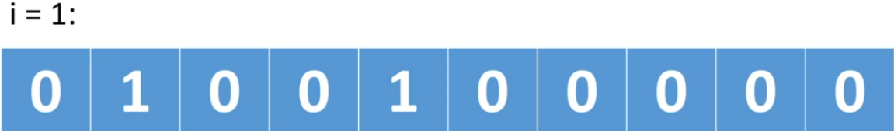  
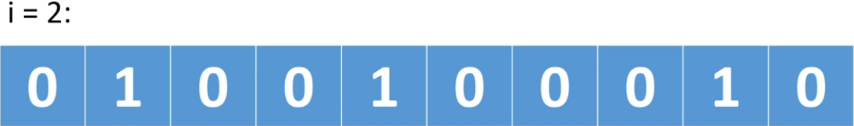  
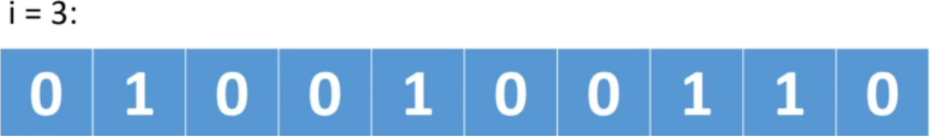  
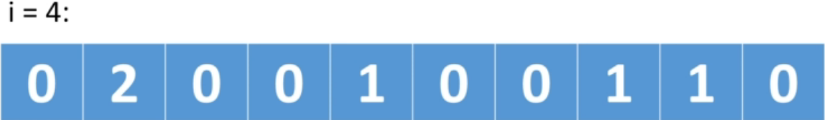  
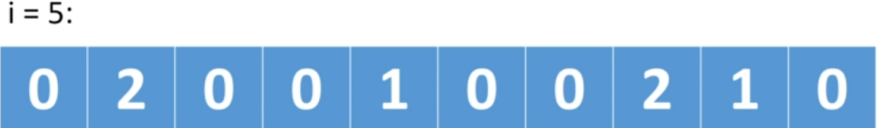  
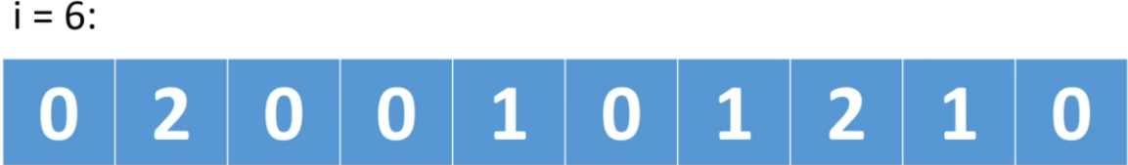  
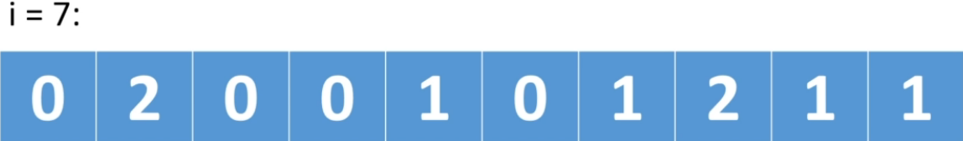  
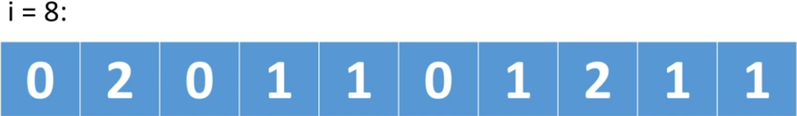  
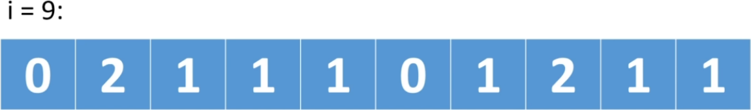  
* At this point we’ve traversed our entire input array and we’ve counted how many occurences of each value we’ve seen.

=> **Now we want to use the counting array to write back the values to the original array**.  
* We traverse the counting array and we would say:  
=> there is zero 1 so we don’t have to do anything.  
=> there’s two 2 so we’re going to write two 2 into the input array.  
=> there’s one 3 so we’re going to write one 3 into the input array.  
=> there’s one 4 so we’re going to write one 4 into the input array.  
=> there’s one 5 so we’re going to write one 5 into the input array.  
=> there’s zero 6 so we don’t have to do anything.  
=> there’s two 8 so we’re going to write two 8 into the input array.  
=> there’s one 9 so we’re going to write one 9 into the input array.  
=> there’s one 10 so we’re going to write one 10 into the input array.

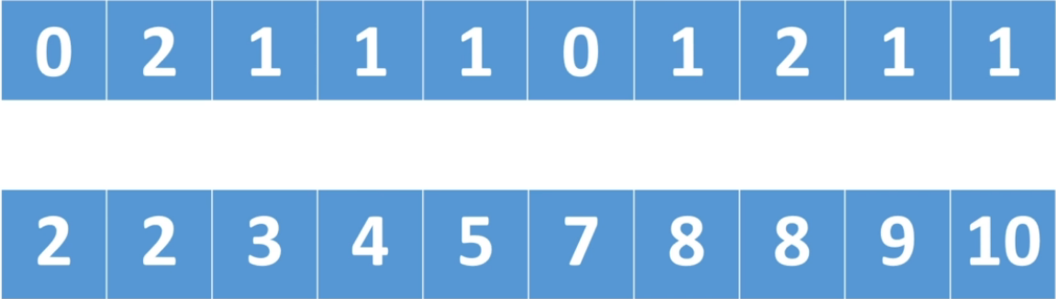  
* Essentially, Counting Sort has 2 phases:  
1) Traverse the input array and count how many of each value we have  
2) Using the counting array, we write values back into the input array  
* We didn’t do any comparisons, we didn’t compare any of the elements against each other.  
* We’re just counting how many of each value we have, that’s why it’s called **Counting Sort**.  
**NOT in-place** => we have to create a counting array and its length will depend on the range of values.  
=> Because of this, **Counting Sort is best used when when the range of values you have is around the same length of the input array**.  
* For example a range of 1000 and only 10 values, you would need to create an array of length 1000.  
**O(n)** => can achieve this because we’re making assumptions about the data we’re sorting.  
**UNSTABLE (the Counting Sort I showed you)** => **If we want the sort** to be **STABLE**, we **have to do some extra steps** => **instead of just incrementing a counter for example, you would perhaps use what’s called a LinkedList in the counting array**.

**Counting Sort (Implementation)**  
**(Implemented my own version before watching this video)**  
* **If we have a range 10 - 20 we want it to translate to indices 0 - 11 so it’s 20 - 10 + 1 = 11**   
**(max - min) - 1**  
* We’re setting  
**int i = min; i <= max; i++**  
=> **because this way we can just write the value of i back to the input array on each iteration**.  
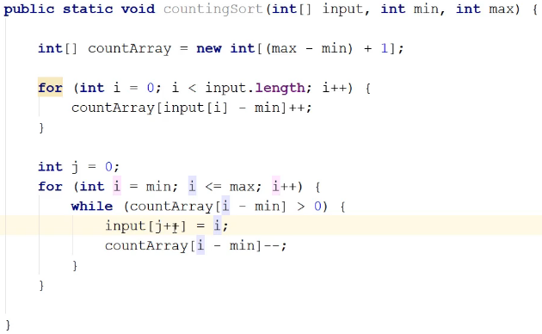  
* In the while loop: remember that each element in the countArray has a count and that count can be > 1.  
* Let’s say we have two 2, so write it and then we decrement the amount of 2 that we have. It will be zero once we’ve written all of them to the input array, at which point we drop out of the loop.  
* We’ve written the loop this way (starting i = min) because then we can just when we’re writing out the number of 1s, i will be 1, when we’re writing out the number of 2s, i will be 2. So we can just stick i in. And j is keeping track of where we are in the input array.

**Radix Sort (Theory)**\* Another algorithm that makes assumptions about the data it’s sorting.  
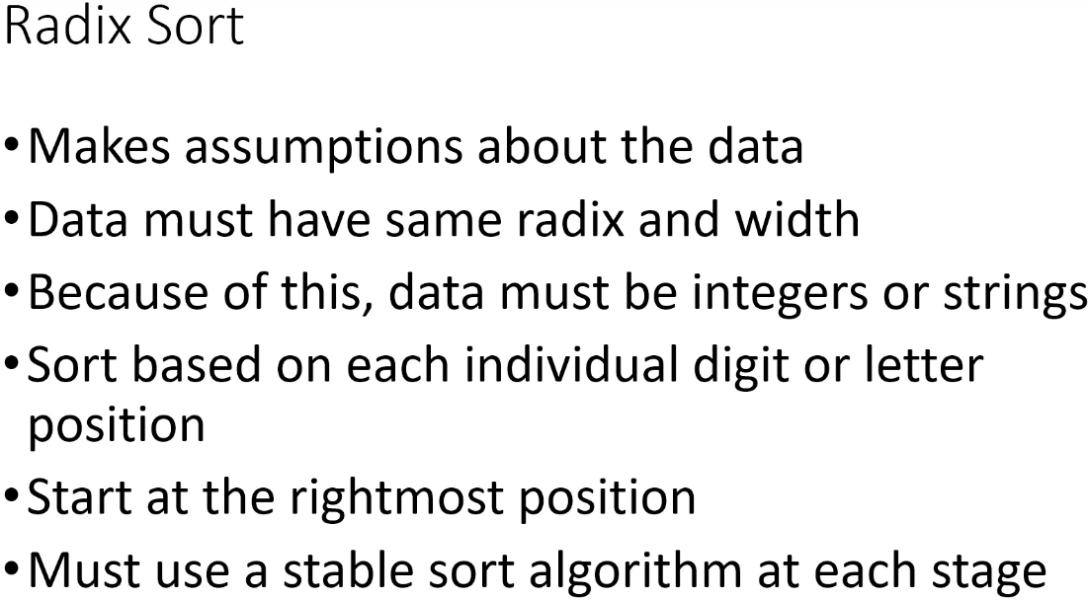  
* Radix => the number of unique digits or values in the case of characters, that a numbering system or an alphabet has.  
* For **decimal system**, the **radix is 10** because there are 10 possible digits in the decimal system (0-9).  
* For **binary numbers**, the **radix is 2** because there are 2 possible digits in the binary system (0-1)  
* For the **English alphabet**, the **radix is 26** because there are 26 letters in the alphabet.  
* Width => the number of digits or letters.  
* For example, 1235 has a width of 4.  
* For example, “Hello” has a width of 5.  
* The Radix Sort assumes that all the values have **the same Radix and the same Width**.  
=> **We can use the Radix Sort to sort integers and strings**.  
* The decimal point isn’t a digit, and so, floating point numbers can’t be sorted using Radix Sort.  
=> **We sort based on each individual digit or letter position**.  
=> **We start at the rightmost position and we sort the digit/letter based on that position**.  
=> **We then we move to the rightmost - 1 digit/letter and we sort based on that**.  
=> We keep doing that until we’ve done all of the digits/letters in the values.  
=> **We have to use a Stable sort algorithm at each stage**.

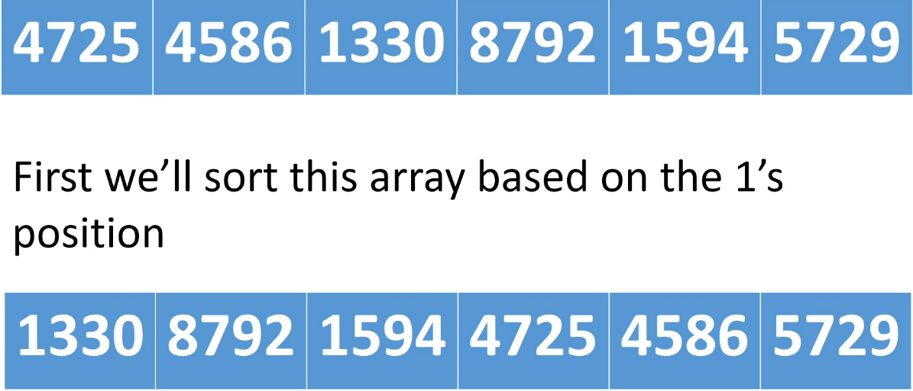  
* They’re all digits and they’re all of width four.  
* We’re sorting by the digit that has the least weight becauase the 1’s position has the least weight in a decimal number.  
* Once we’ve done that, the bottom array will be the result.  
* At the bottom you can see that the rightmost digit of each value is sorted: 0 2 4 5 6 9.  
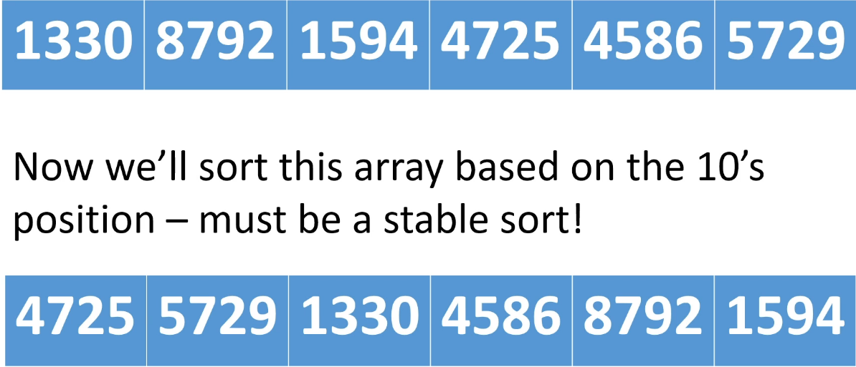  
* At the bottom you can see that the rightmost - 1 digit of each value is sorted: 2 2 3 8 9 9.  
* **The algorithm we use at each stage has to be STABLE, because for example: 4725 and 5729 => the number 4725 came before 5729 when comparing based on 1’s and so when comparing based on 10’s they both have the same digit but the order has to be preserved so 4725 has to still come before 5729. Same for the 100’s and so on**.  
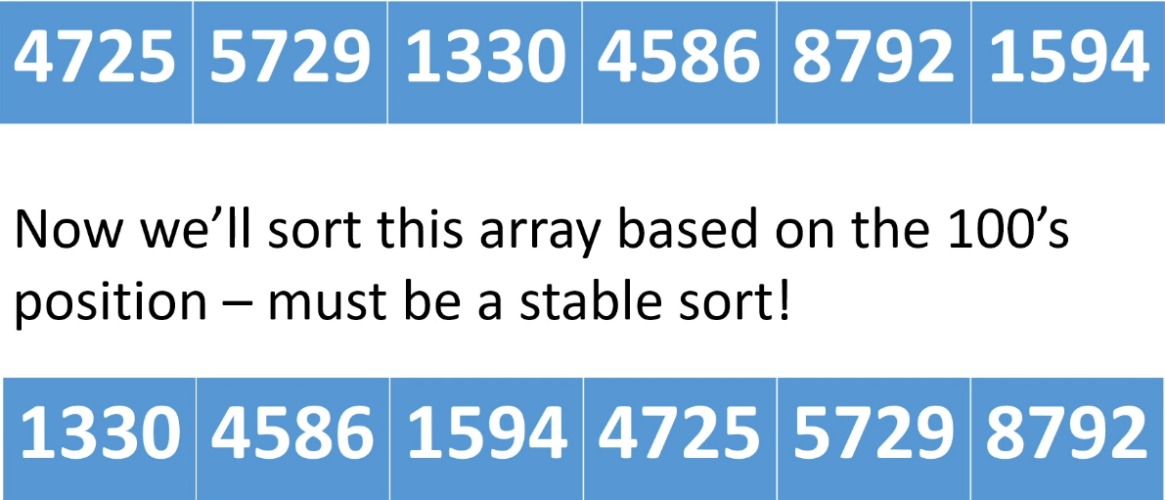  
* At the bottom you can see that the rightmost - 2 digit of each value is sorted: 3 5 5 7 7 7.  
* The relative positions have been preserved: 4725, 5729, 8729.  
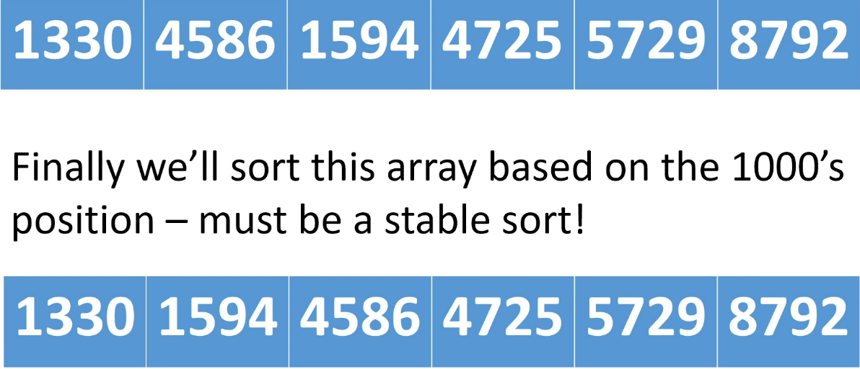  
* At the bottom you can see that the rightmost - 2 digit of each value is sorted: 1 1 4 4 5 8.  
* If that sort wasn’t stable, this wouldn’t work because for example at the final stage if 1594 could cross 1330, we wouldn’t get the correct sorted order.  
* **The key is that we’re sorting from the least significant digit - the one with the least weight when it comes to the value, to the most significant digit and at every phase it’s a Stable sort**.  
* Because it’s a Stable sort at each stage, all of the previous sorts that we’ve done still count, it kind of looks like we’re not sorting at each stage, but we are, the data is gradually becoming more sorted. And the fact that we’re using a Stable sort algorithm means that on that final sort, when we’re sorting on the most significant digit, values that have the same most significant digit will not switch relative positions.  
=> **Because we’re using a Stable sort algorithm at each phase and we’re going from the least significant digit/letter to the most significant digit/letter, the results of previous sorting phases are preserved**.  
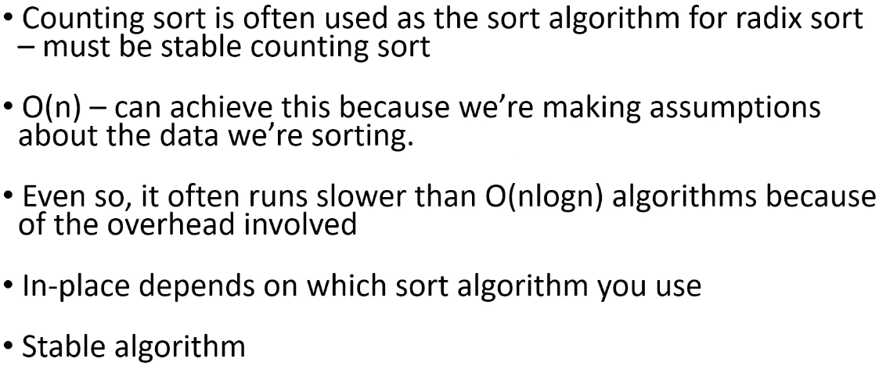  
**O(n)** => can achieve this because we’re making assumptions about the data we’re sorting.  
* **Even so, it often runs slower than O(nlogn) algorithms because of the overhead involved**.  
* **Overhead** => you have to isolate each individual digit/letter at each phase and so there’s overhead involved just to figure out **what value you’re supposed to be sorting at each phase** and because of that, even though it can achieve O(n), it often runs a little bit slower than that.  
**In-place => depends on which sort algorithm you use**  
**Stable => this is key to making it work, that the sorts in earlier phases aren’t being undone as we sort based on the more significant positions.**

**Stable Counting Sort (Theory)**  
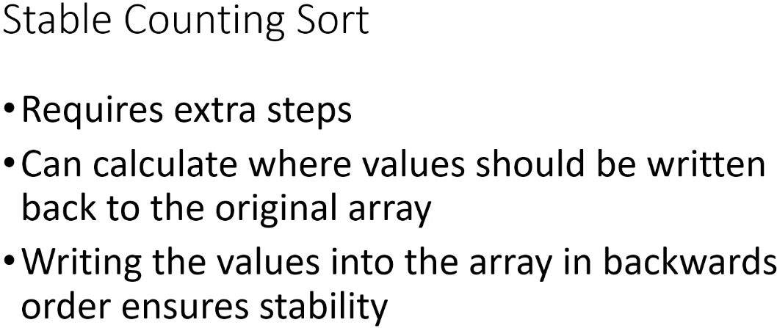  
* **The implementation that I’m going to show you calculates where values should be written back to the original array, and then by writing the values into the array in backwards order, we get stability**.  
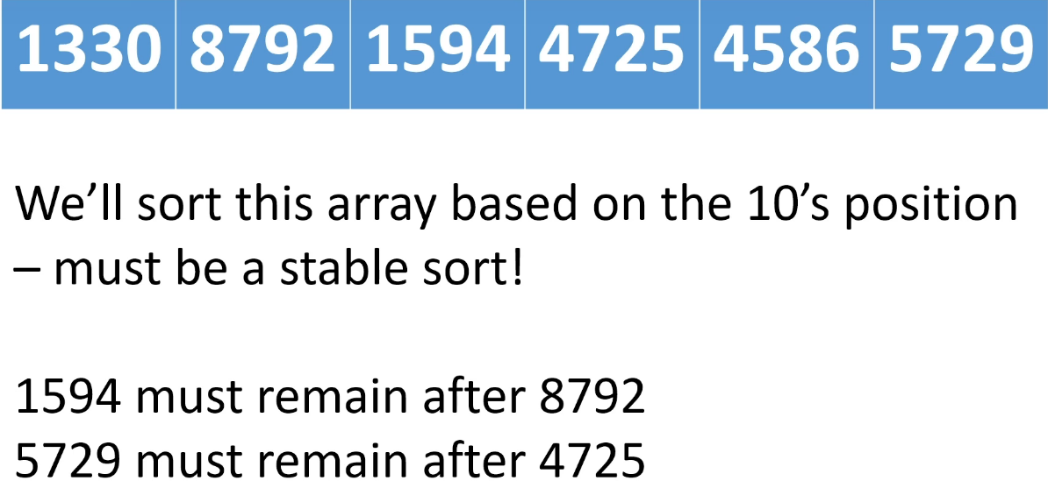

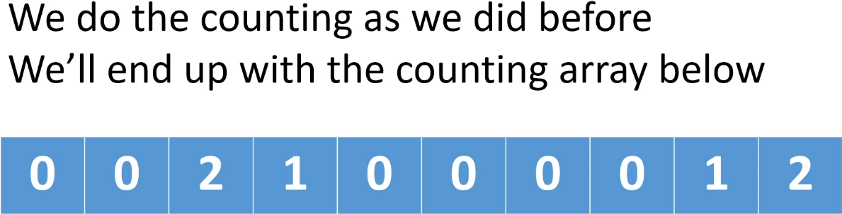  
=> two 2, one 3, one 8, two 9.

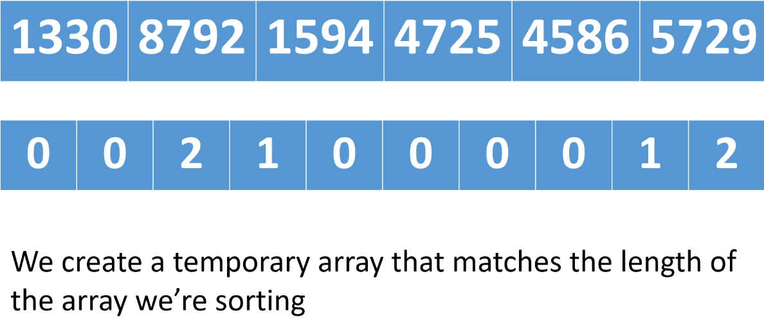  
=> **We create an array of length 6**.  
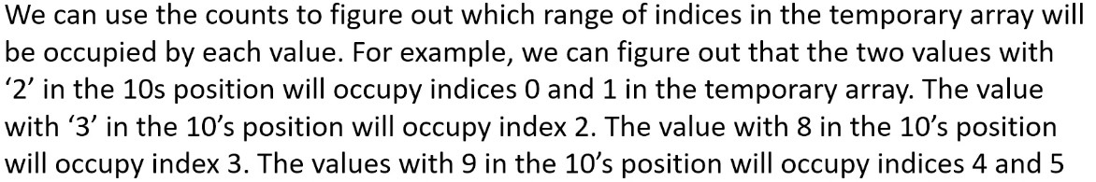  
=> Becauise we know how many values we’re sorting and how many of each value have a specific digit in their 10’s position, we can figure out what range of positions the values with a specific digit in the 10’s position are going to occupy.

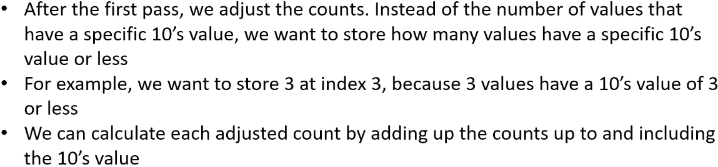  
* After we’ve done our first counting pass and we’ve ended up with out usual counting array, we adjust the counts.  
=> Instead of just keeping the number of values that have a speicifc 10’s digit, we want to store how many values have a specific 10’s digit or less.  
* For example, at index 3 in the counting array which currently contains the number of values that have a 3 in the 10’s, instead of that, we want to know how many values have 3 or less in the 10’s position.  
=> In this case, that’s 3 values because we have two values that have 2 in the 10’s position and one value that has 3 in the 10’s position and so we have three values that have a 3 or less in the 10’s position. And we can calculate how many values have a specific digit or less by summing up all the counts that come before it.  
=> By summing up 0 0 2 1 we get 3 which is how many values have a 3 or less in the 10’s position.  
* After we’ve adjusted the counts, we have:  
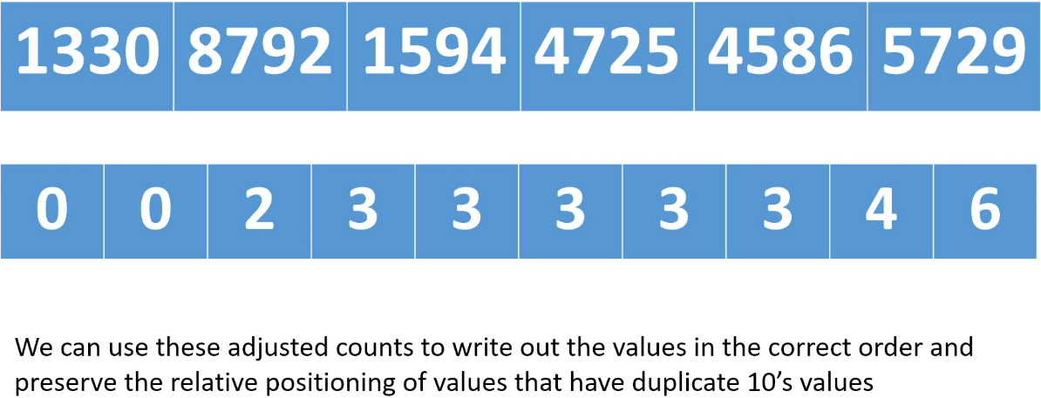  
* The last position is always going to equal the number of values we have because it’s highest or less.

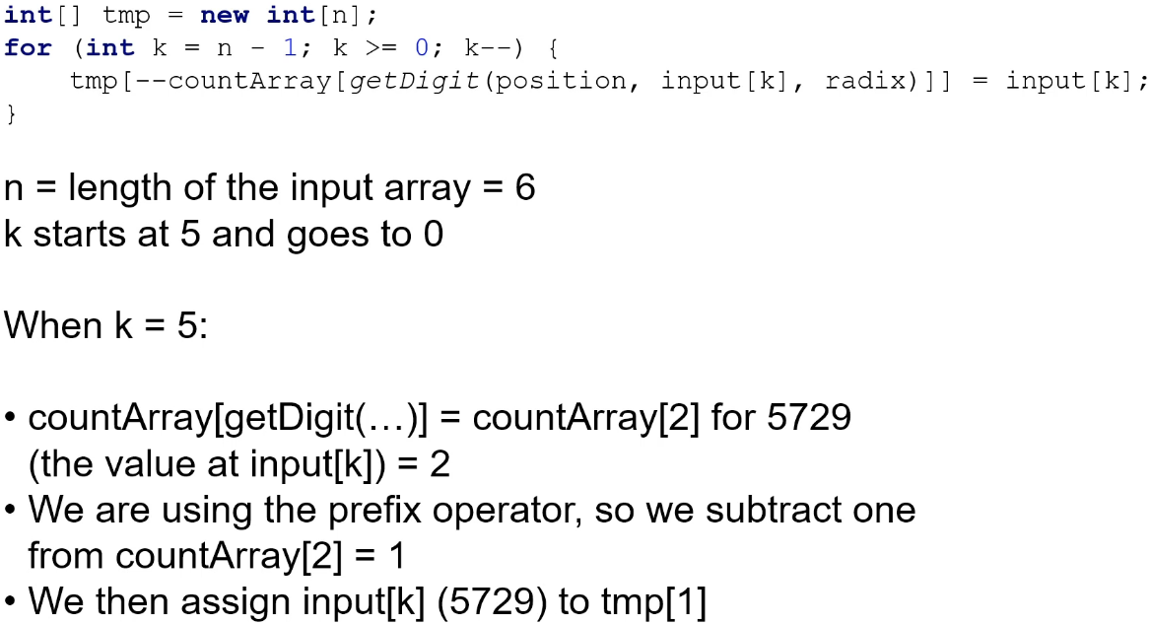  
=> We initialize the tmp array of length 6.  
=> Then we traverse the array backwards (from right to left) because this is going to make us write the rightmost values before the leftmost values and that’s what’s going to ensure stability.  
* When k = 5, we’re going to get the digit in the 10’s position and we’re going to get it for input[k], that’s 5729:  
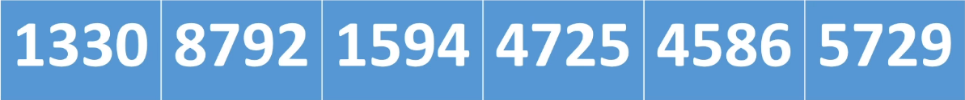  
=> We’re going to look at countArray[2] because the getDigit() all is going to return 2.  
* So we’re going to get the 10’s digit of input[5] (57**2**9) which is **2**. And then we’re going to decrement the value at countArray[2] which is going to give us 1 and we’re going to use that result as the index into our tmp array => tmp[1]. So tmp[1] will contain 5729.  
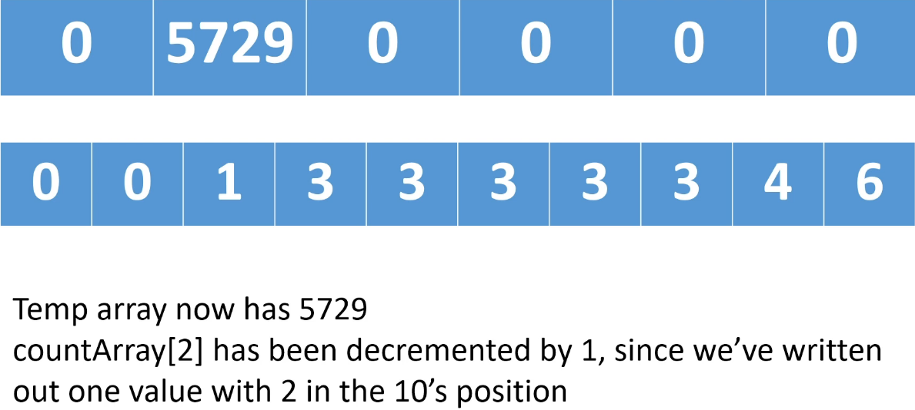  
* **We’ve decremented countArray[2] by one because we’ve written one value with 2 in the 10’s position**.  
* **Notice it went to tmp[1] and so the second value that has 2 is going to go into tmp[0].**  
* And because we’re writing right to left in the input array, we’re writing rightmost values before leftmost values. That means if we have a duplicate, the rightmost duplicate will be written to the right of the leftmost duplicate and that’s what’s preserving the stability.  
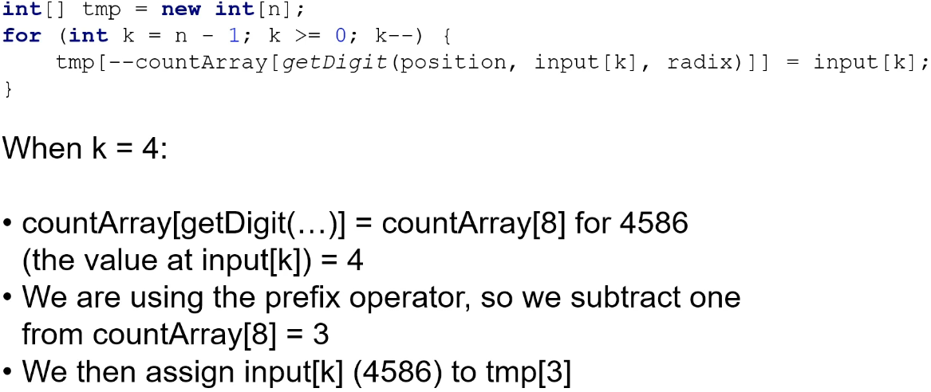  
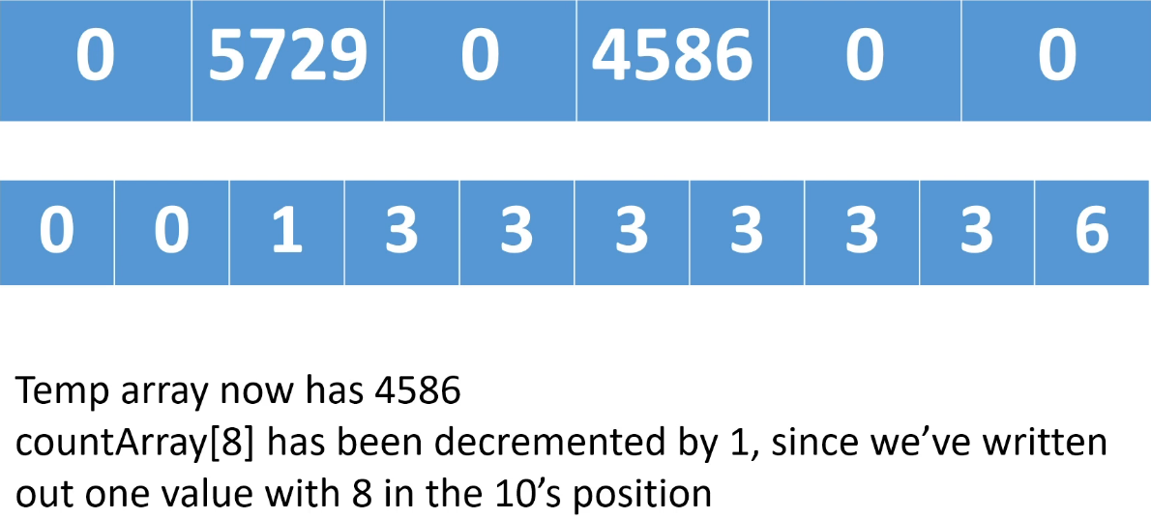

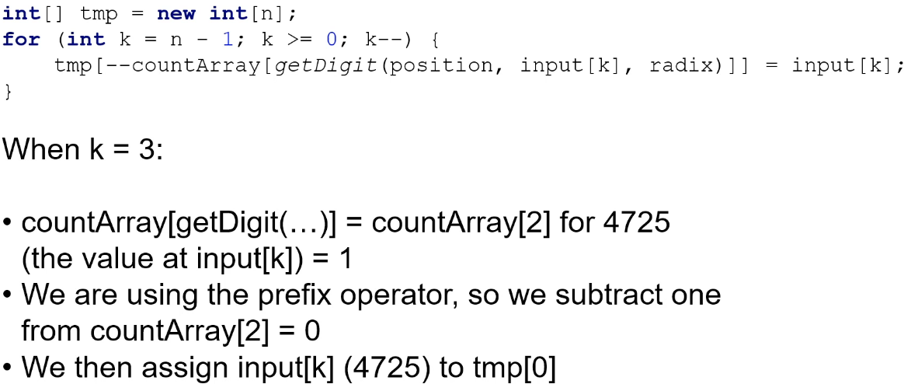

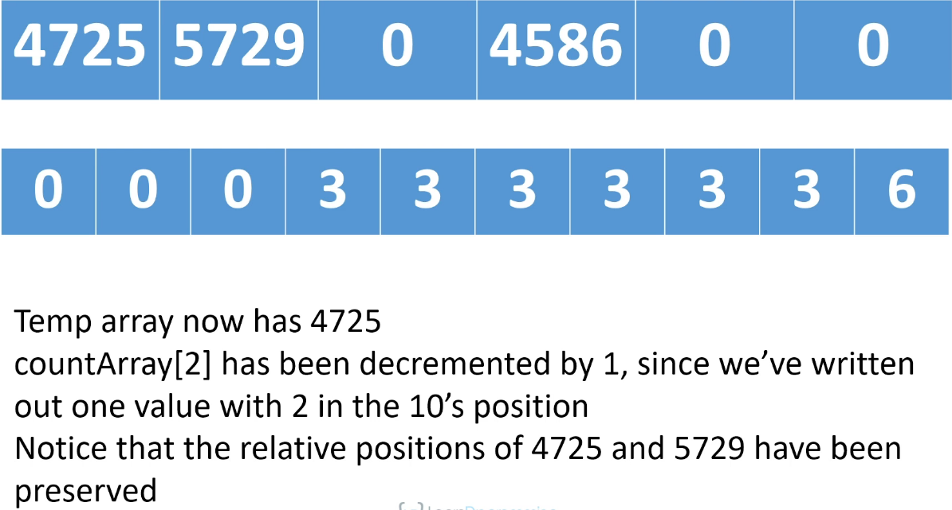  
* Notice that we have preserved the relative positions of 4725 and 5729 because we’re going right to left.  
=> So when we write the rightmost duplicate value, we write that value into the rightmost position of the set of positions for that 10’s value. And so we knew that the two values that had 2 in the 10’s position, were going to occupy positions tmp[0] and tmp[1]. And so we write the rightmost value in the original array into position tmp[1] and the leftmost value into position tmp[0] and by doing that we have preserved the relative positions so this is a stable sort.

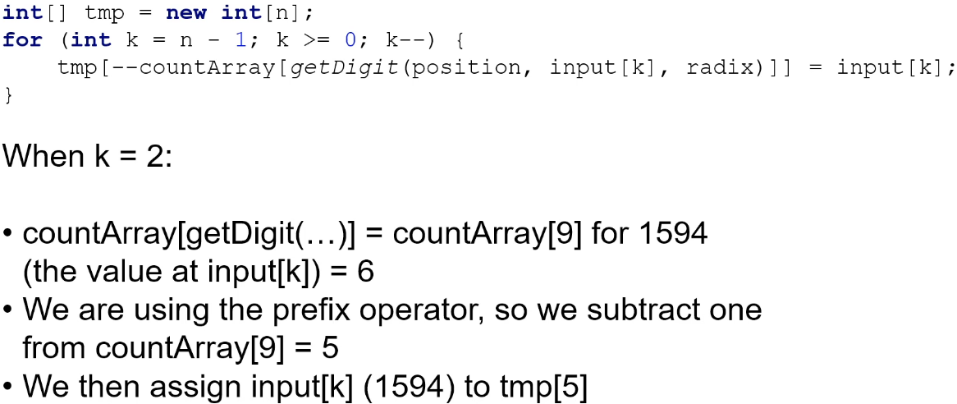

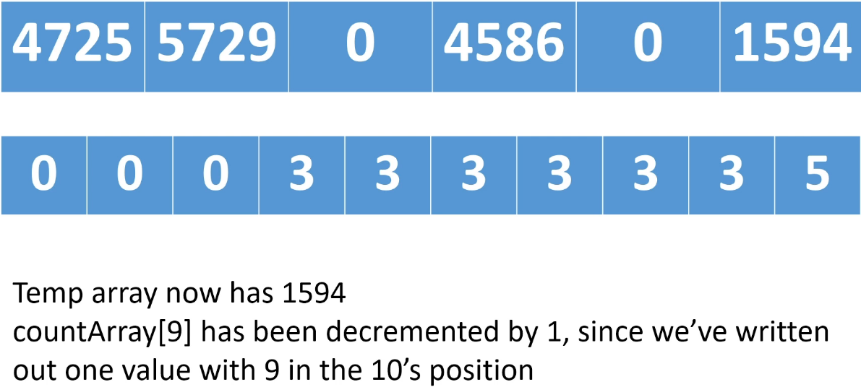

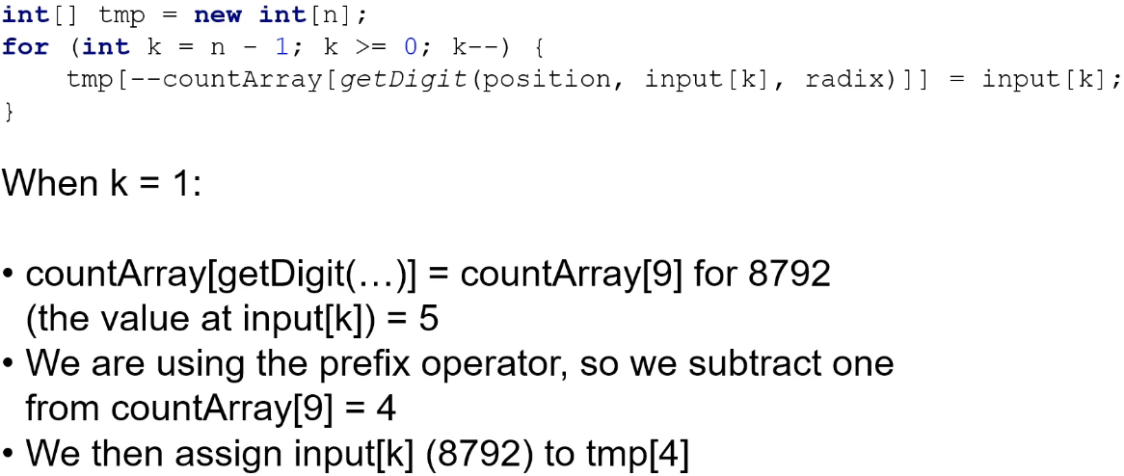

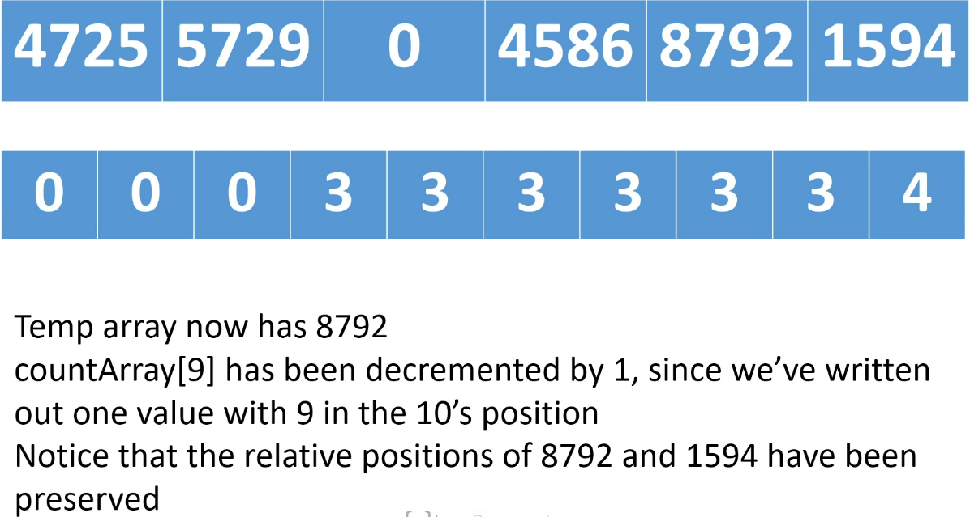

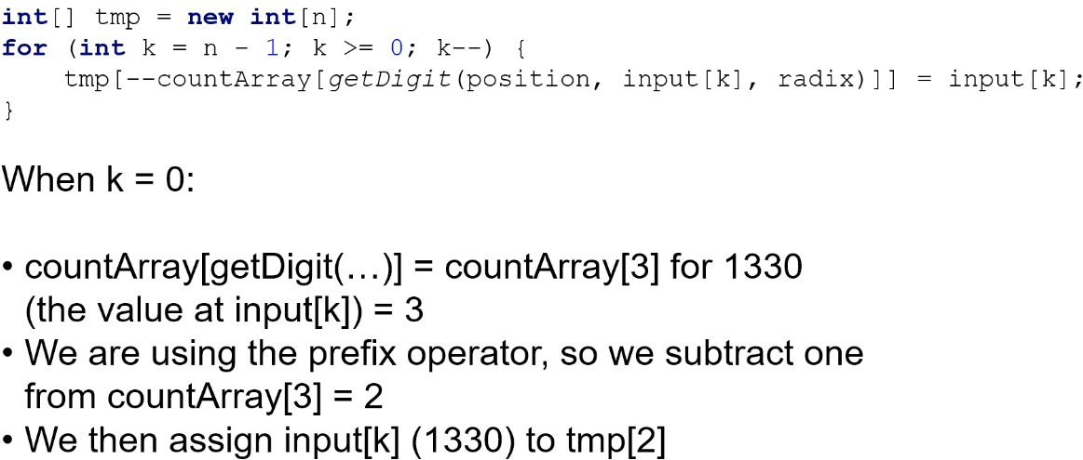

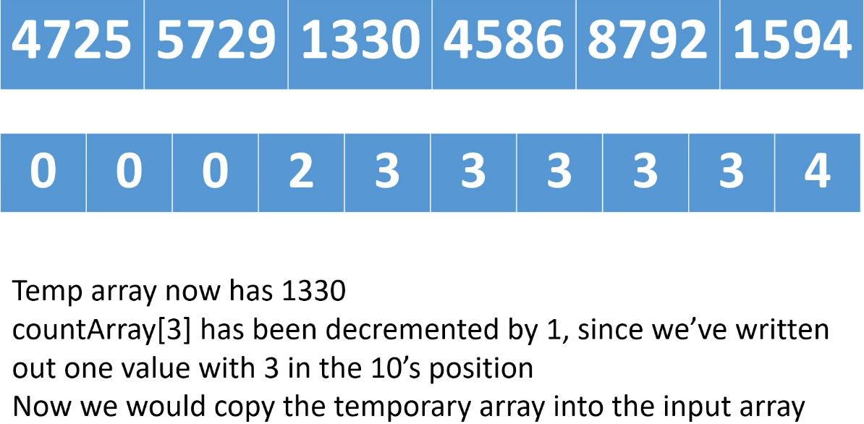

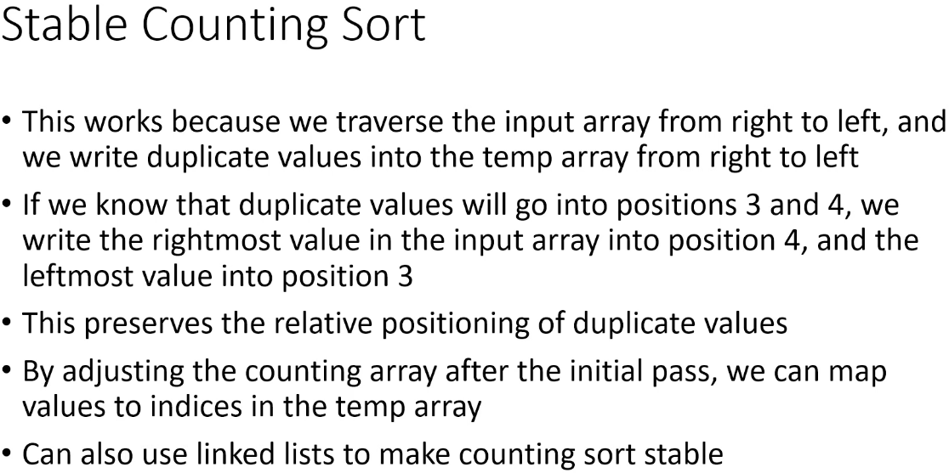  
* So by adjusting the countArray after the initial pass, so that we instead of storing just the raw counts, instead we store how many values have that value or less - so for us it was how many values have a specific digit or less in the 10’s position, we can use those adjusted counts to map values back to indices in the tmp array.  
* Another way of doing this is to use something called LinkedList - we haven’t covered those yet. So instead of just using counts the way that we did, you can actually store a list of the actual values at each position in the countArray and then you write the list out backwards.  
* Obviously there would be one more step in our implementation which is copying the tmp array back into the input array.

**Radix Sort (Implementation)**  
**(Implemented my own version of Radix Sort and Stable Counting Sort before watching this video)**  
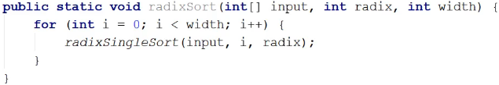  
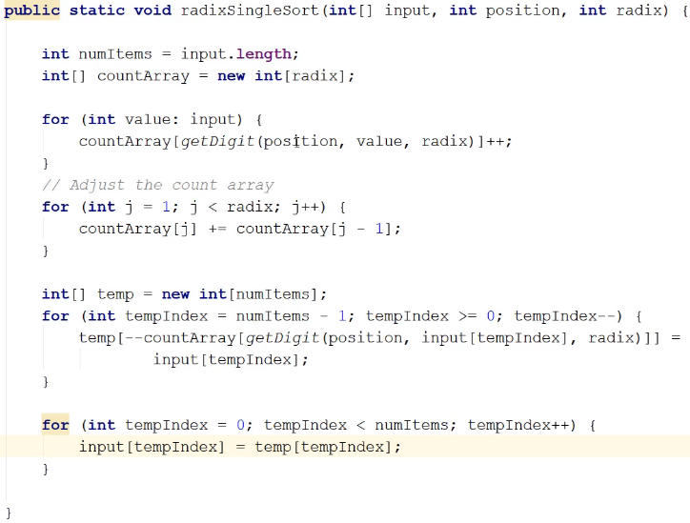  
  
* An unstable sort would not work because it would undo previous sorts when we’ve sorted on less significant digit positions.  
* That’s it for sorting algorithms right now. We’re going to see a few more later in the course after we’ve covered some more data structures because they make use of those data structures.

**Sorting Arrays Using the JDK**  
* Suppose you have an array that you want to sort in a Java application.  
* Do you implement one of those algorithms to sort the array?  
=> Well, you can, especially if you can use one of the linear sort algorithms that make assumptions about the data. But if you can’t do that, if you can’t make any assumptions about tha data, you don’t have to implement any of those algorithms because it’s Java and we have the JDK at our disposal.  
* The JDK contains an Arrays class and that class has methods that sort arrays.  
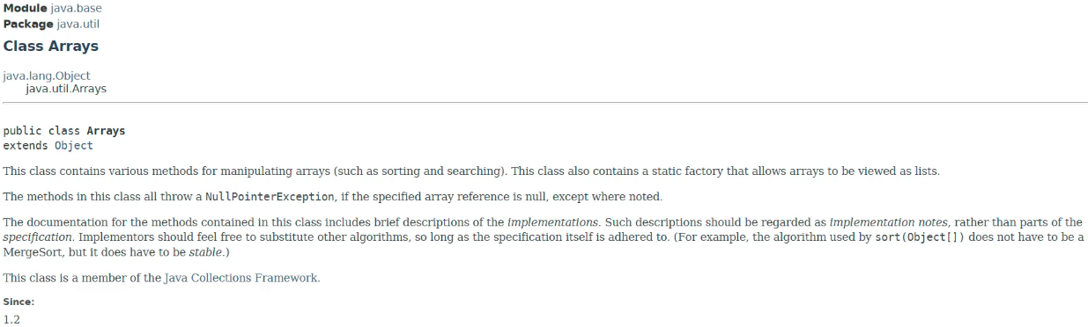

**Java Arrays class**  
<https://docs.oracle.com/javase/9/docs/api/java/util/Arrays.html>  
* If you want to **sort objects**, you have to tell the Runtime how to sort those objects and so you would **implement the Comparable Interface**.  
* There are also methods that sort the entire array or just a part of the array.  
**Arrays.sort()**  
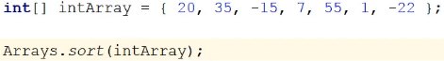  
* We might ask: what sort algorithm is it using?  
=> right-click the sort() and Go To Declaration.  
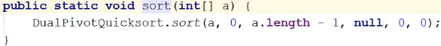  
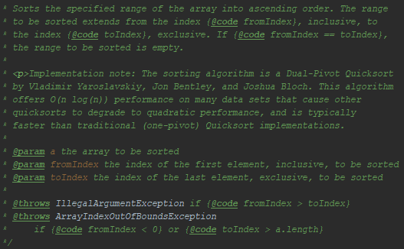  
**Arrays.parallelSort()**  
  
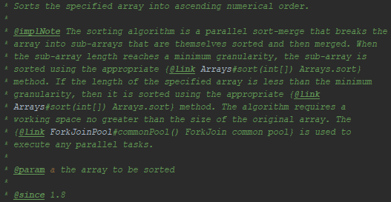  
* It’s also using Threads and that’s why it’s called parallelSort().  
* So this sort might be faster for larger datasets.  
* You would have to run some benchmarks to decide whether to just call sort() or parallelSort().  
* **The point is that it’s good to understand the different types of sort algorithms but you don’t necessarily have to implement them yourself**.  
* You’ll see the same thing when we look at some of the upcoming Data Structures.  
* **Java has a lot of support for commonly used Data Structures so you rarely have to implement the Data Structure yourself. There is often a class in the JDK that has already done it for you**.  
* Or if there isn’t, you can usually find a **Third-party library** that has an implementation you can use.  
* The bottom line here is that you don’t have to write the sort code when you want to sort an array, you have methods available to you in the JDK and so, unless you want to use Counting or Radix Sort, or unless for some reason you don’t want to use a DualPivotQuicksort or you don’t want to use a Merge Sort - Quicksort hybrid, you’ll typically just go ahead and use one of the sort methods in the JDK.  
* And if you want to sort an array of objects, remember that you’ll have to implement the Comparable Interface so that the method knows how it’s supposed to order your objects when it’s doing the sort.

**Sort Algorithms Challenge #1**

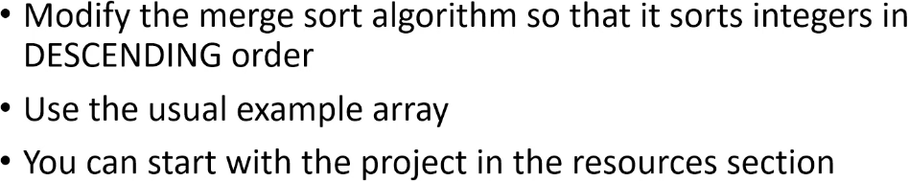  
* **I strongly encourage you to actually do these challenges**.  
* **Even if you struggle and you don’t figure it out, you’re going to be a lot farther ahead by trying**.

**Sort Algorithms Challenge #1 Solution**  
**(Implemented the challenge for my own version of Merge Sort)  
(Implemented the challenge for the course version of Merge Sort)**   
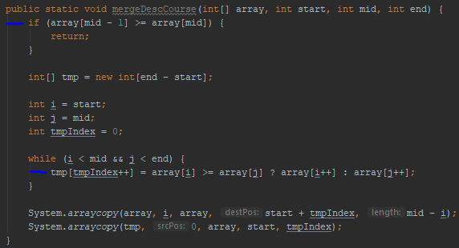

**Sort Algorithms Challenge #2**

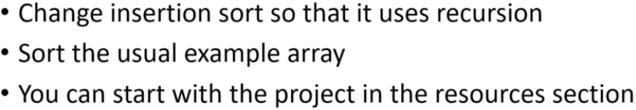

**Sort Algorithms Challenge #2 Solution  
(Implemented the challenge before watching this video)**  
* Iterative:  
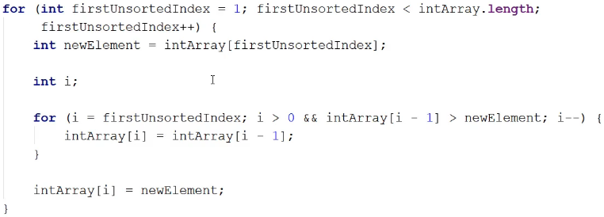

* Essentially we need to think about what’s happening on each iteration of the outer loop.  
* What’s happening is on each iteration, we’re expanding the sorted partition by 1.  
* In the beginning we’re assuming that the very first element in the array is sorted and then we pick off the first element in the unsorted partition and we insert it into the sorted partition and that way we expand the sorted partition by 1.  
=> It would be nice to have a method that we can call with the number of items that we want to sort.  
=> If we start out with the first 2 items and we sort them and then we sort the 3 items and then 4 items and then 5 items and then 6 items and then 7 items, in our case we’ll have ended up sorting the entire array.  
* So we’re going to move our code into a method that accepts an array and the number of items we want to sort.  
* Recursive:  
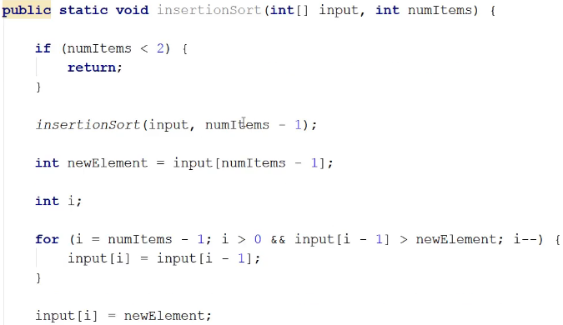  
* So when we’re called with 2 items or more, which means that we have work to do, before we sort the items we’re called with, we’re going to sort numItems - 1.  
* So if we’re called in the beginning to sort 7 items, we’ll say: okay, first sort the first 6 items and then after we’ve sorted the first 6 items, we’ll sort that final item.  
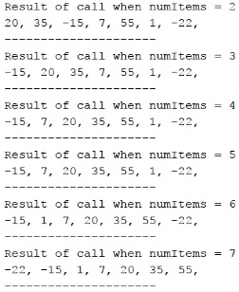  
* So instead of using a loop to increase the sorted partition from left to right, we’re using recursion.  
* Each recursive call handles 1 element and so each recursive call grows the sorted partition by 1.

**Sort Algorithms Challenge #3**

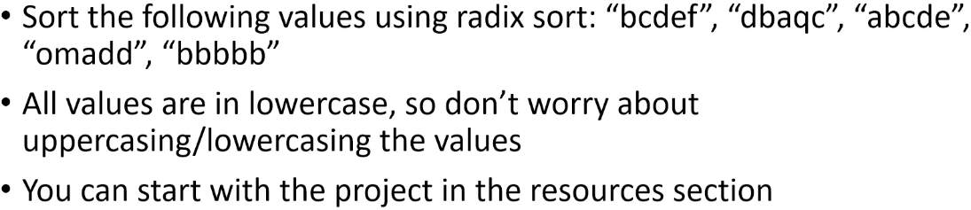

**Sort Algorithms Challenge #3 Solution**  
**(Implemented the challenge before watching this video)**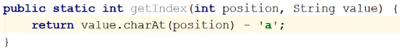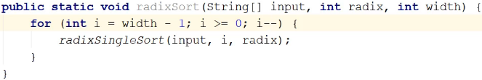  
* As you can see from these challenges, once you know an implementation of a sort algorithm, it’s not really all that difficult to modify it to sort different types of data or to sort in descending order.  
* The most important thing is that you understand the steps that an algorithm takes to sort a set of values because once you know these steps involved with the sort algorithm, you can then code the implementation that you need, to do what you want to accomplish.

**Resources**  
Shell Sort Wikipedia article  
<https://en.wikipedia.org/wiki/Shellsort>  
Dr. Dobbs article on Tail Recursion  
<http://www.drdobbs.com/jvm/tail-call-optimization-and-java/240167044>  
Java Arrays class  
<https://docs.oracle.com/javase/9/docs/api/java/util/Arrays.html>